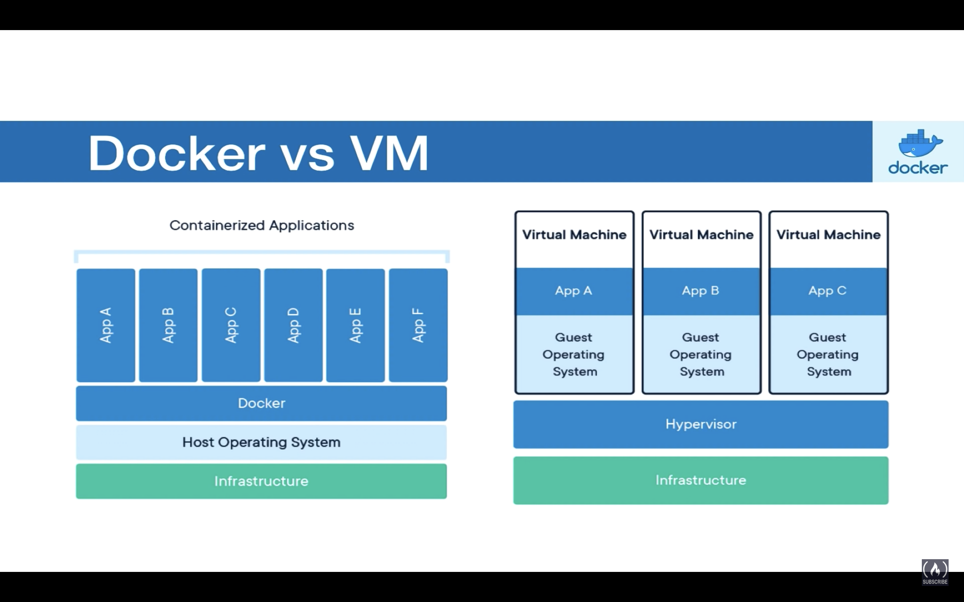

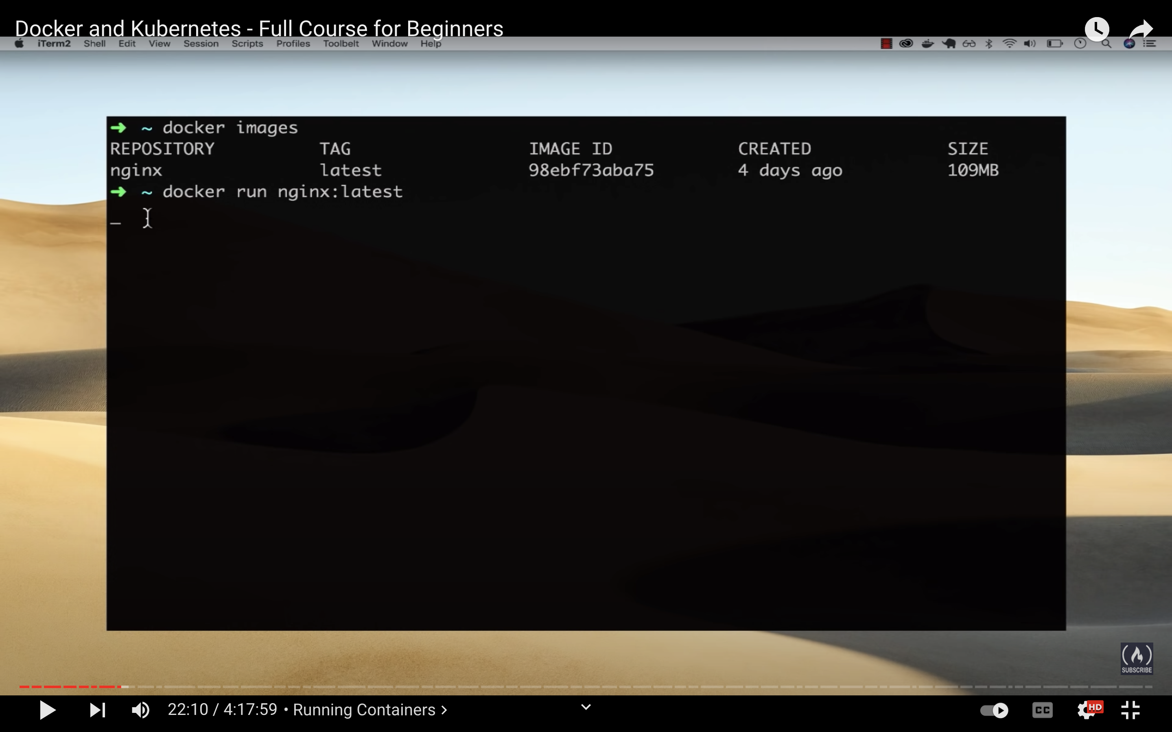

The container is actually running in the background.

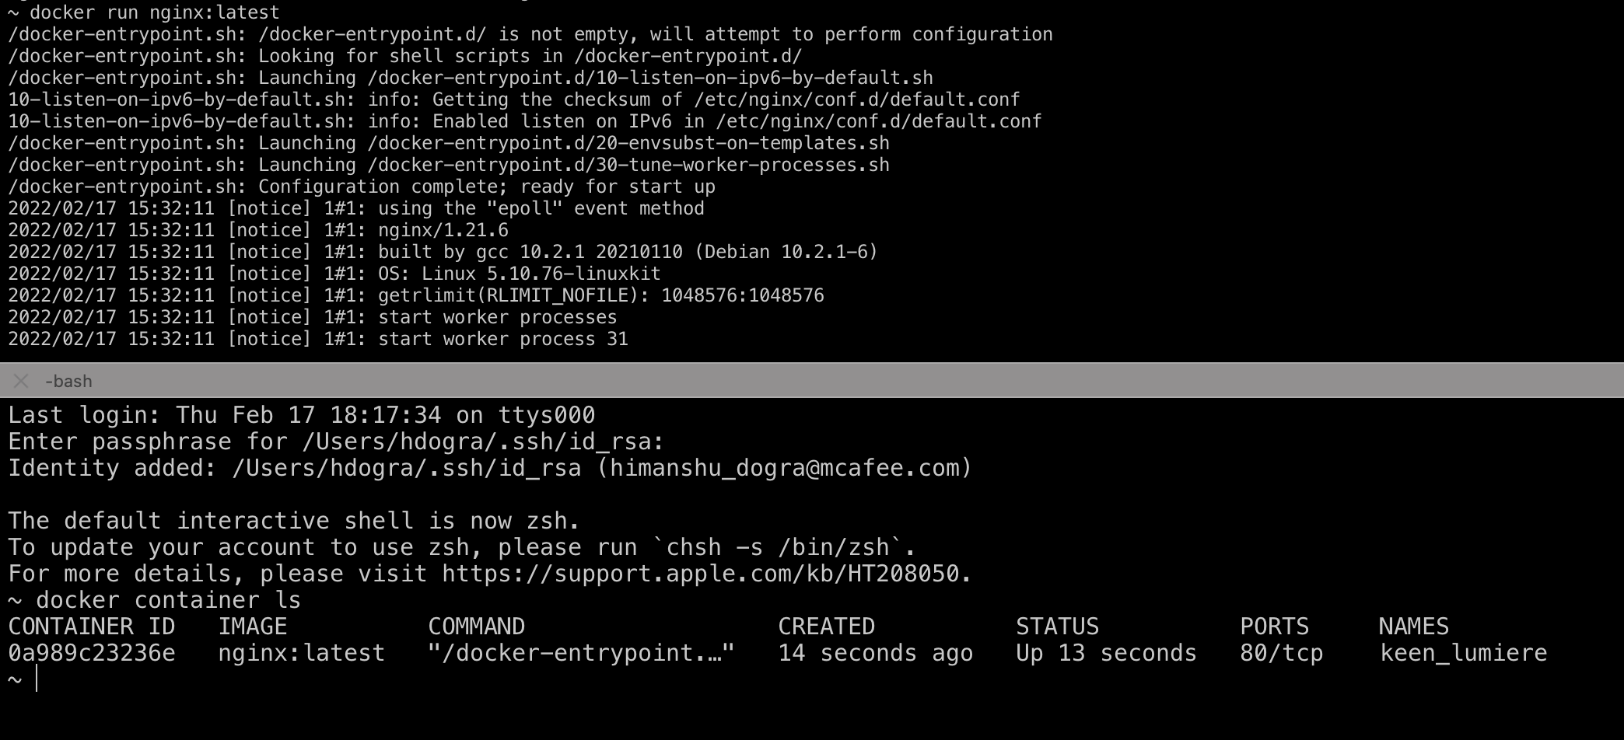

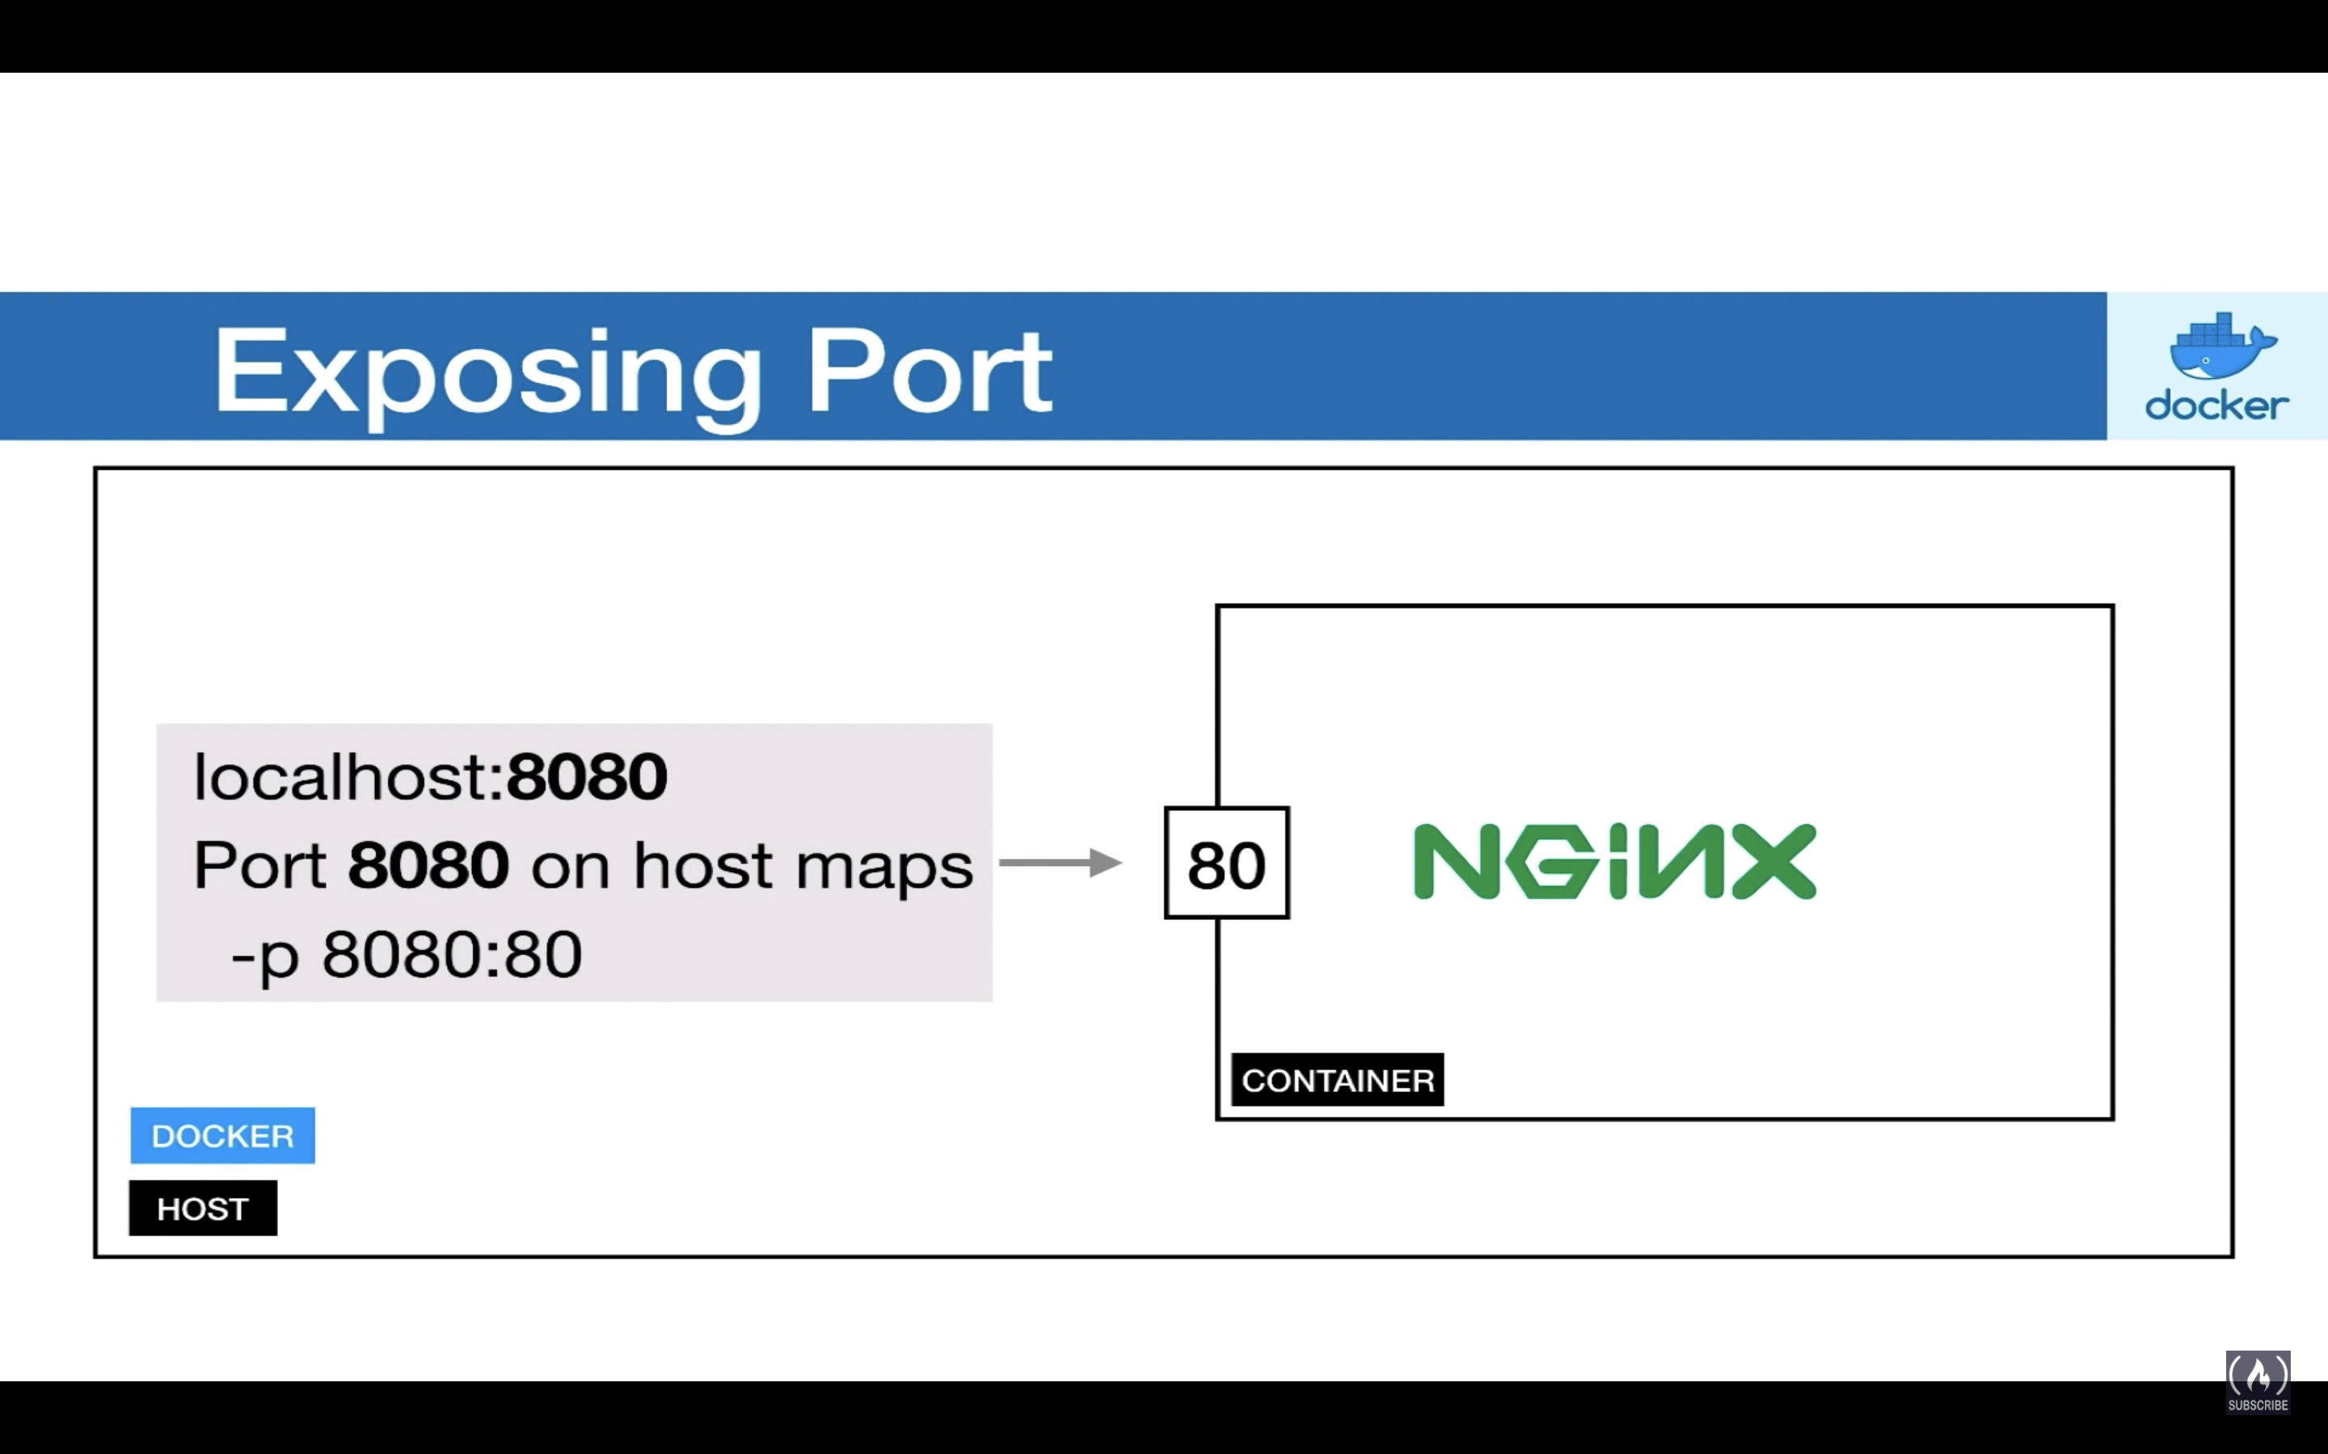

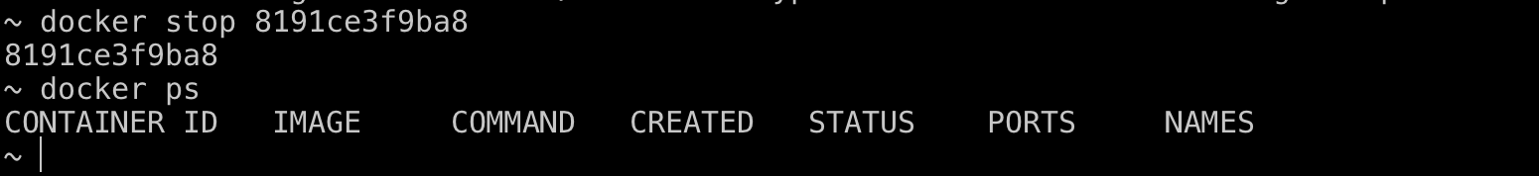

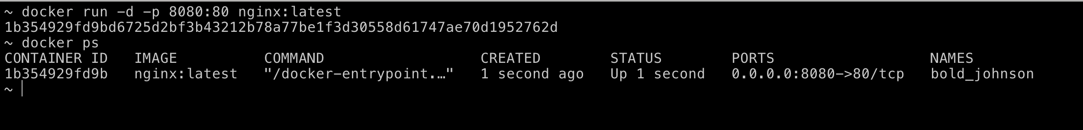

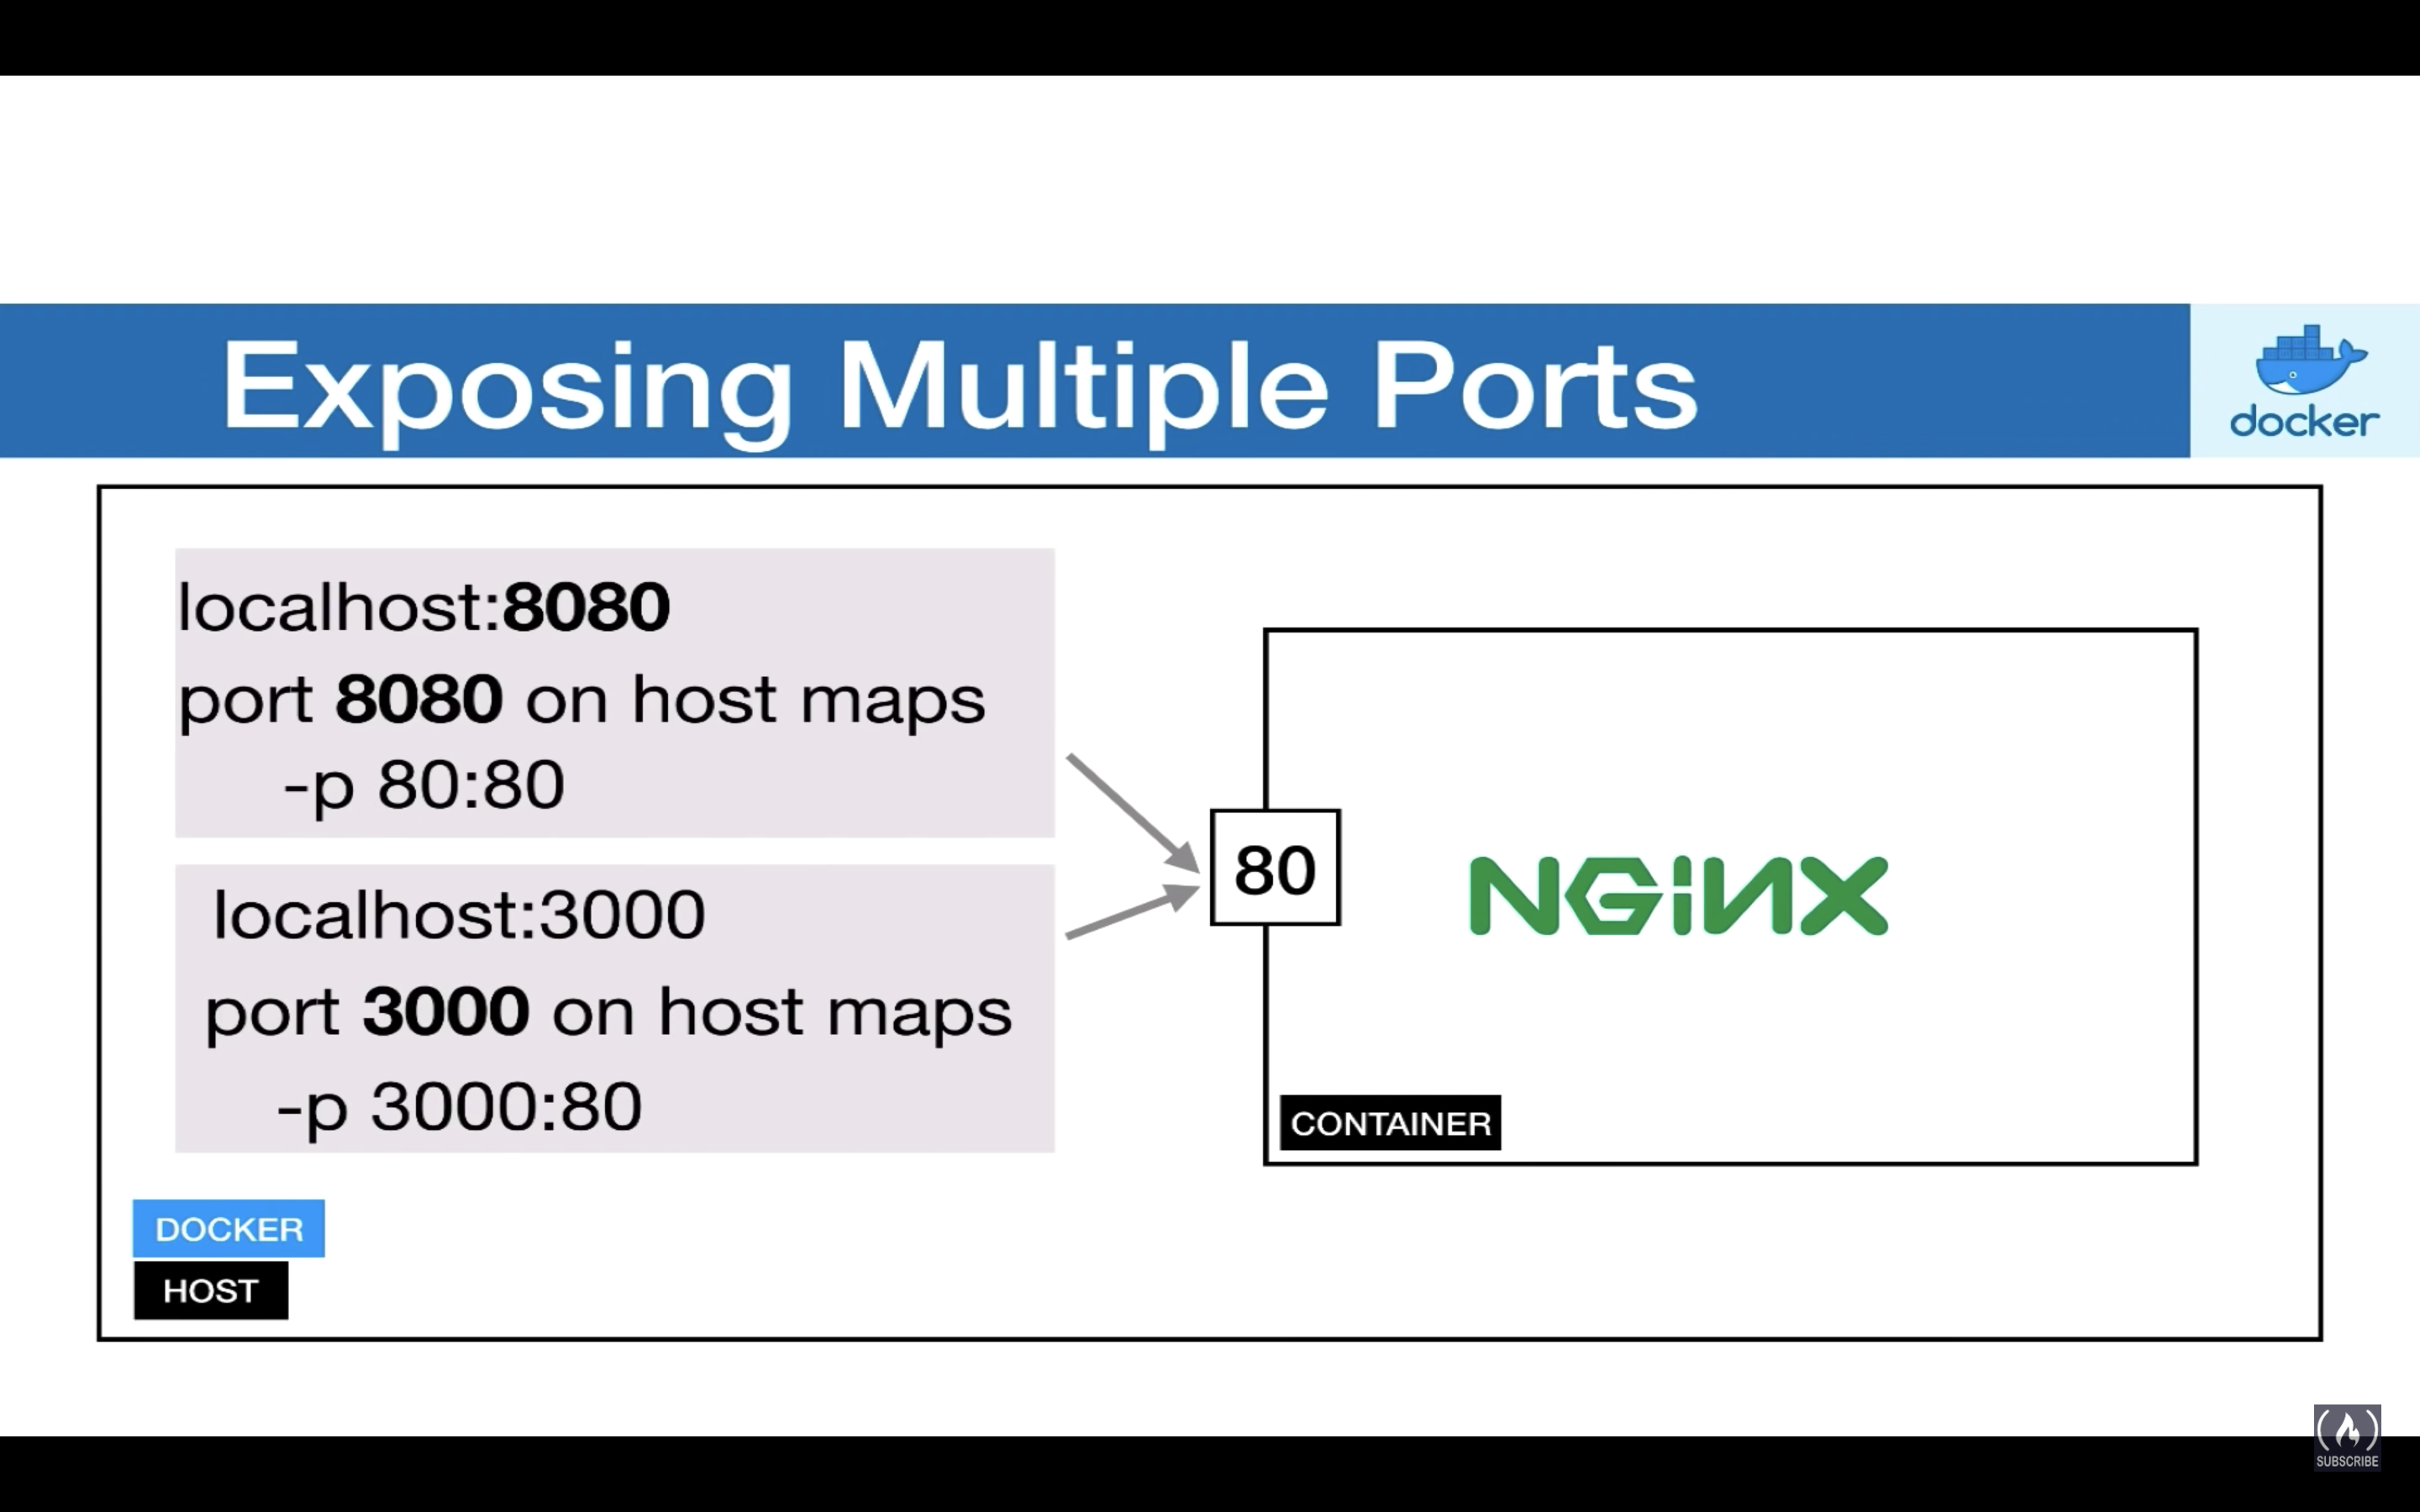

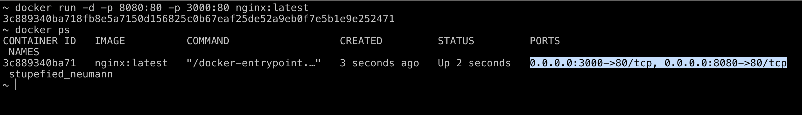

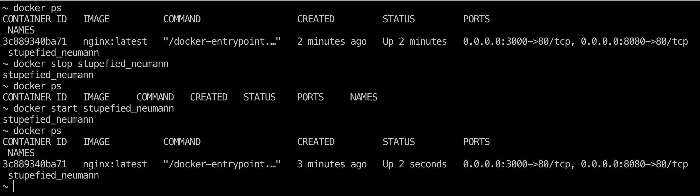

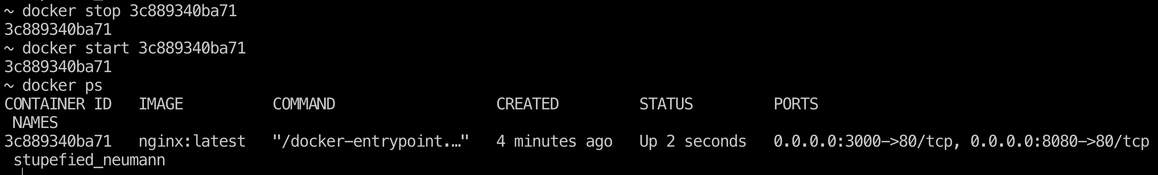

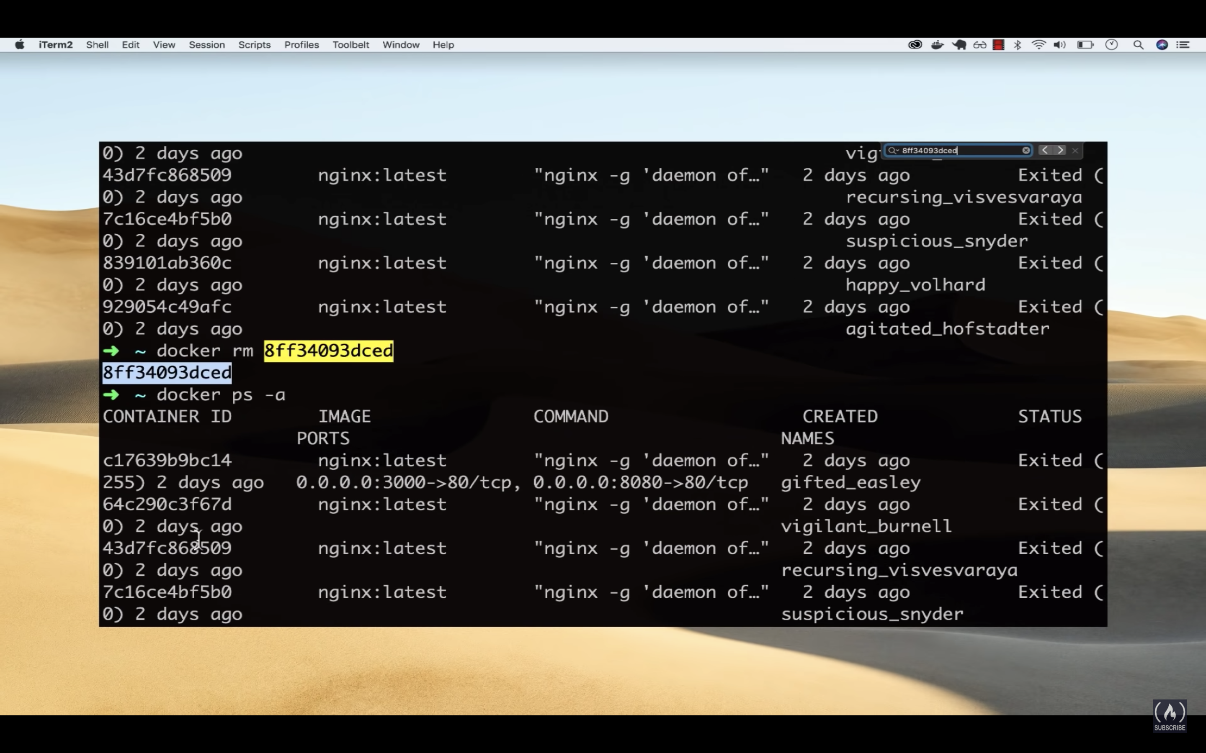

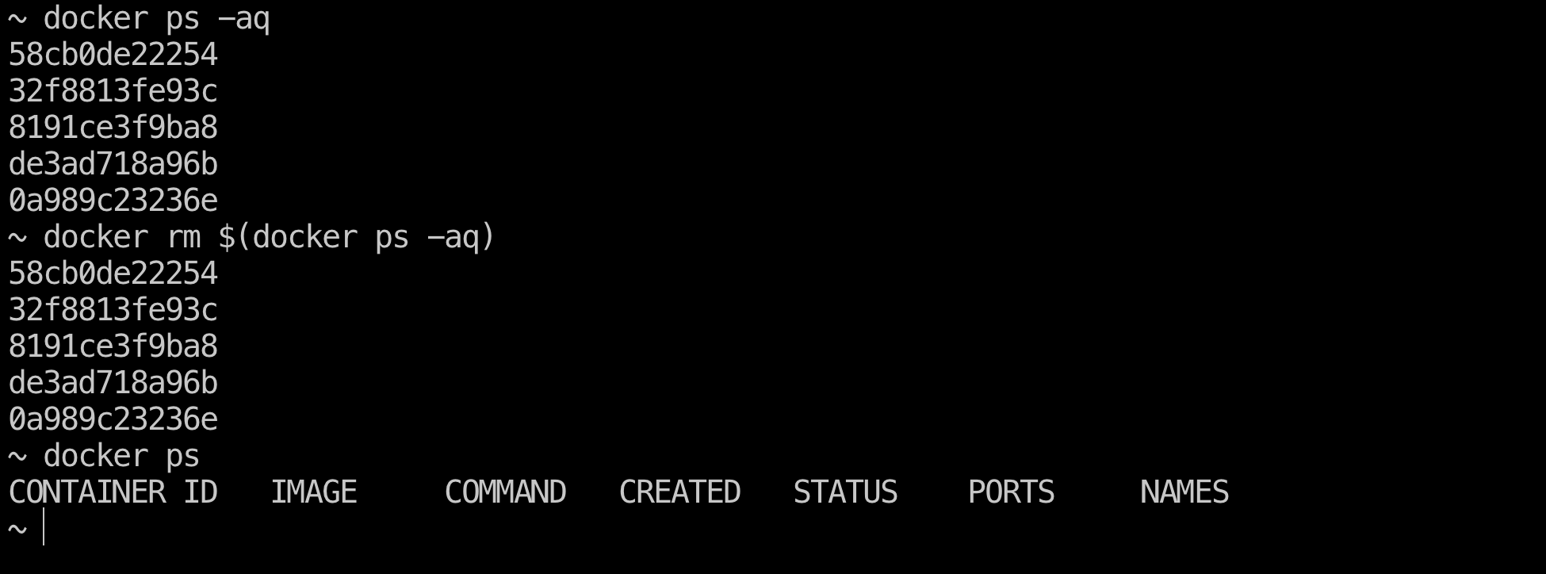

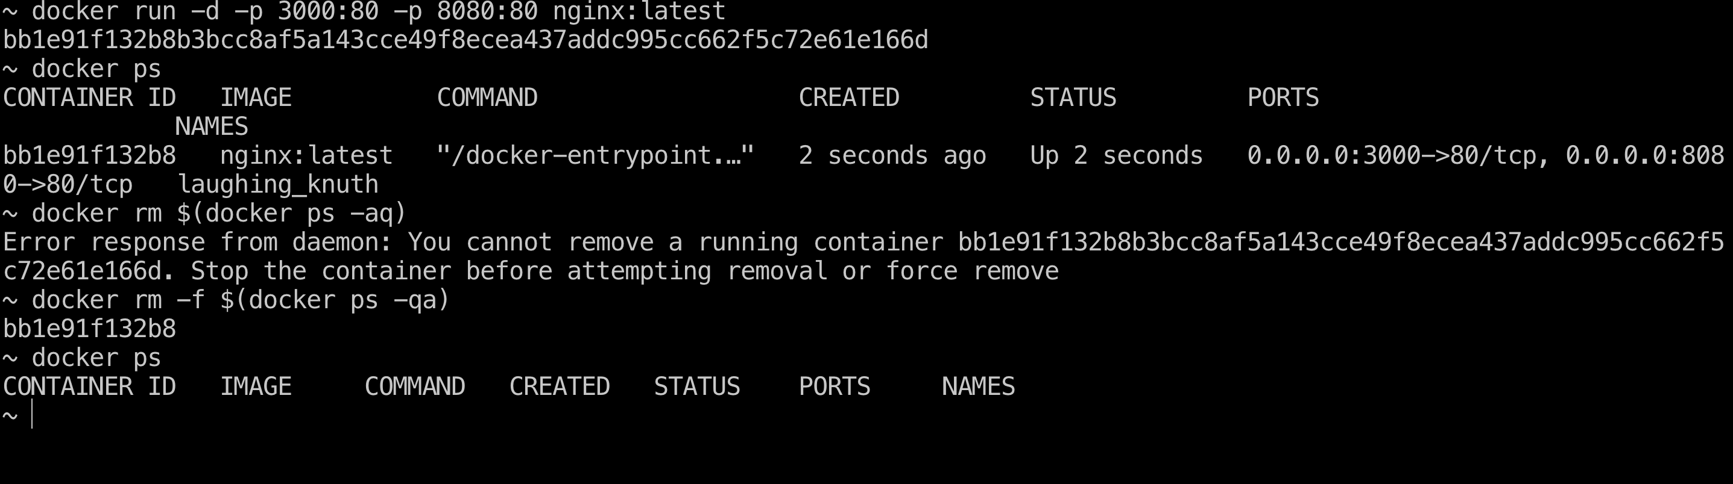

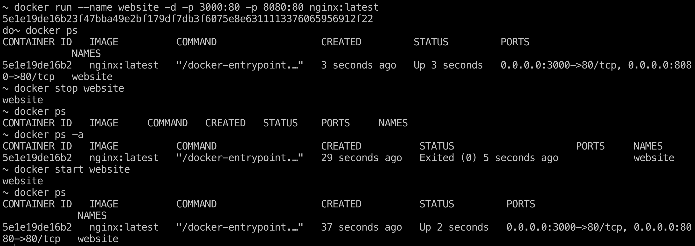

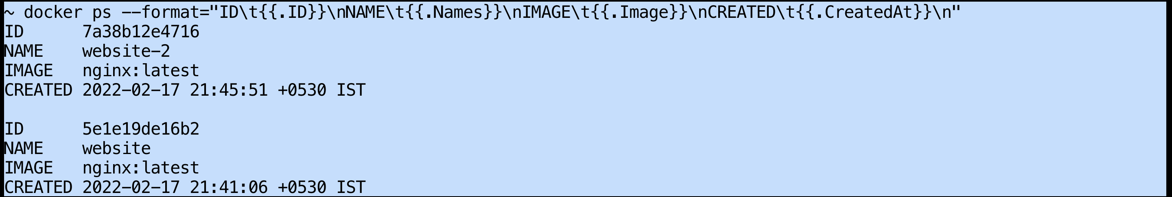

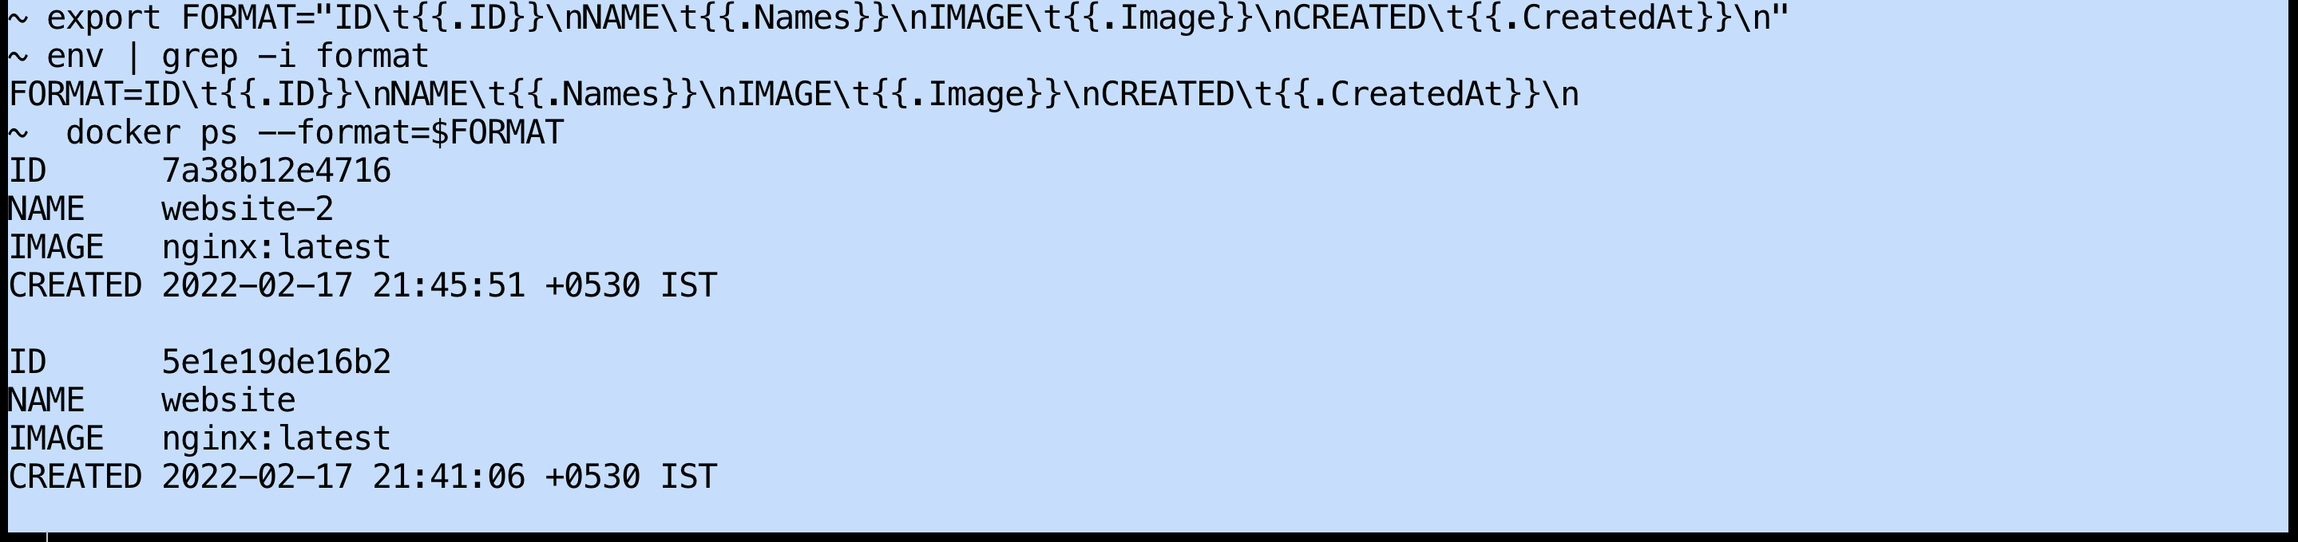

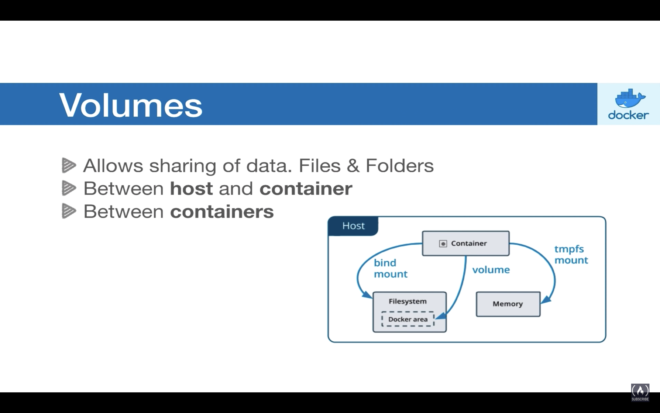

Volume allows us to communicate b/w host&containers, also b/w containers

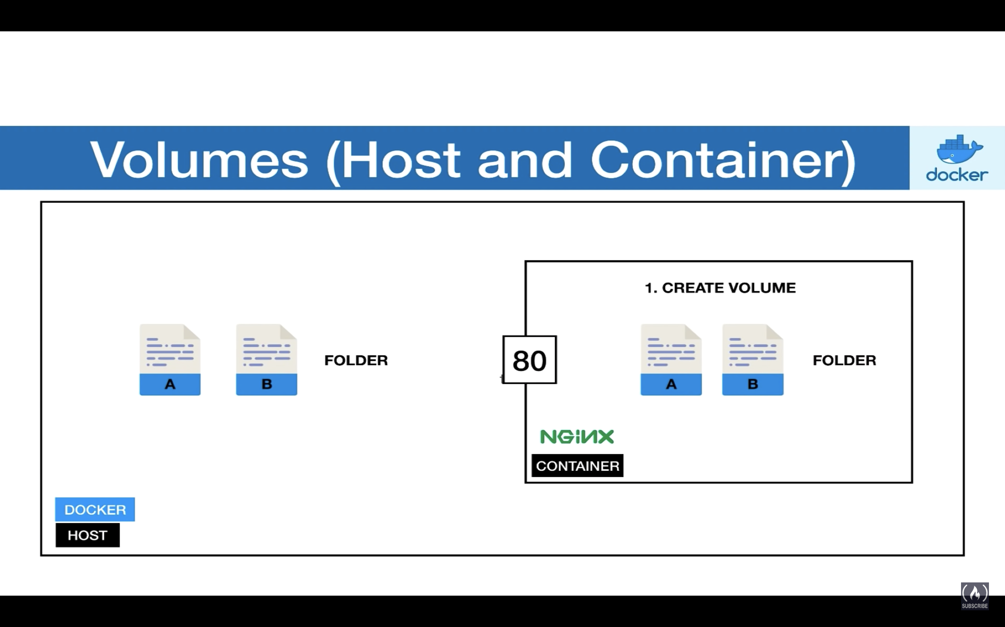

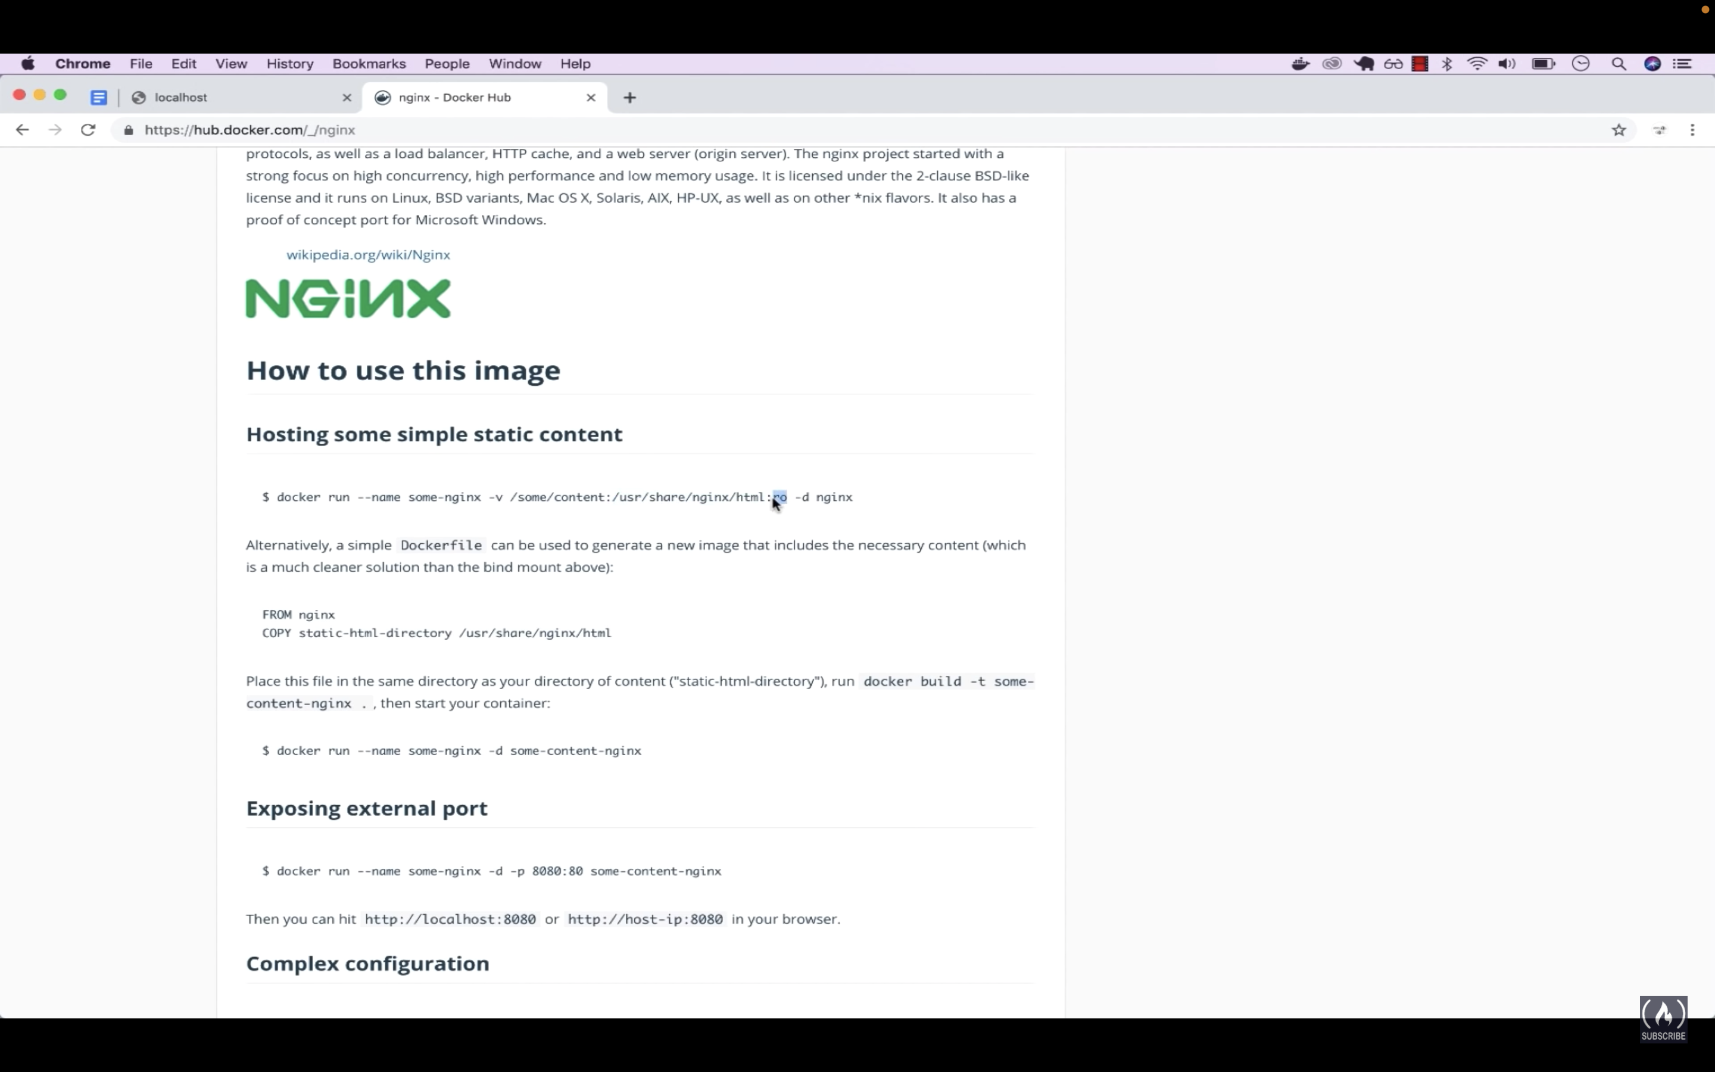

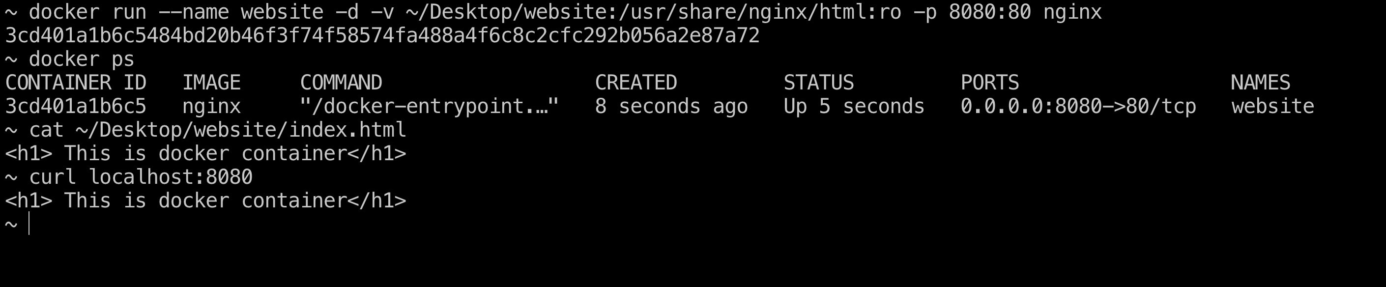

Only RO mode

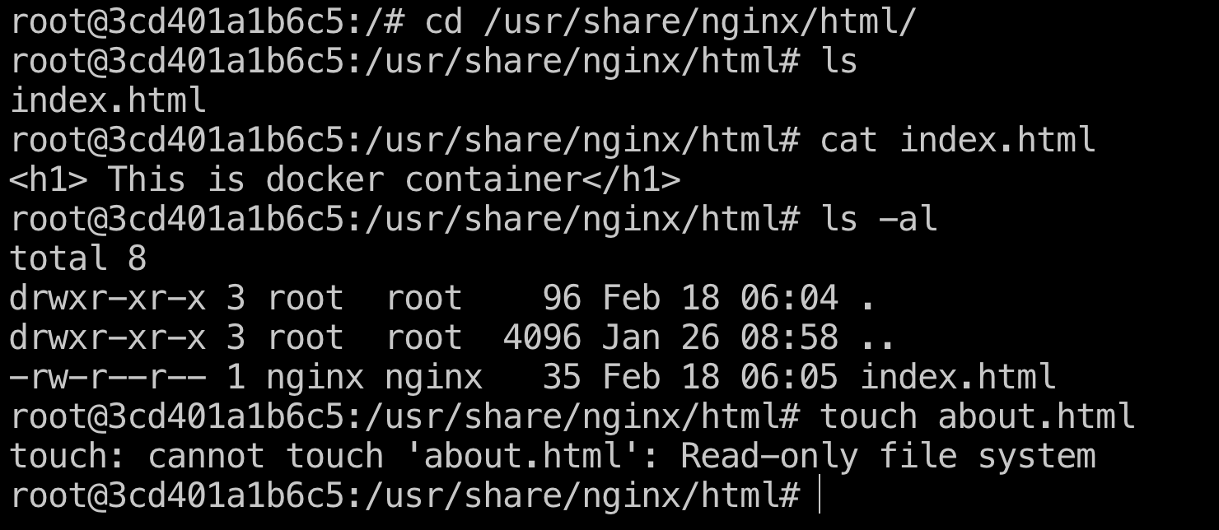

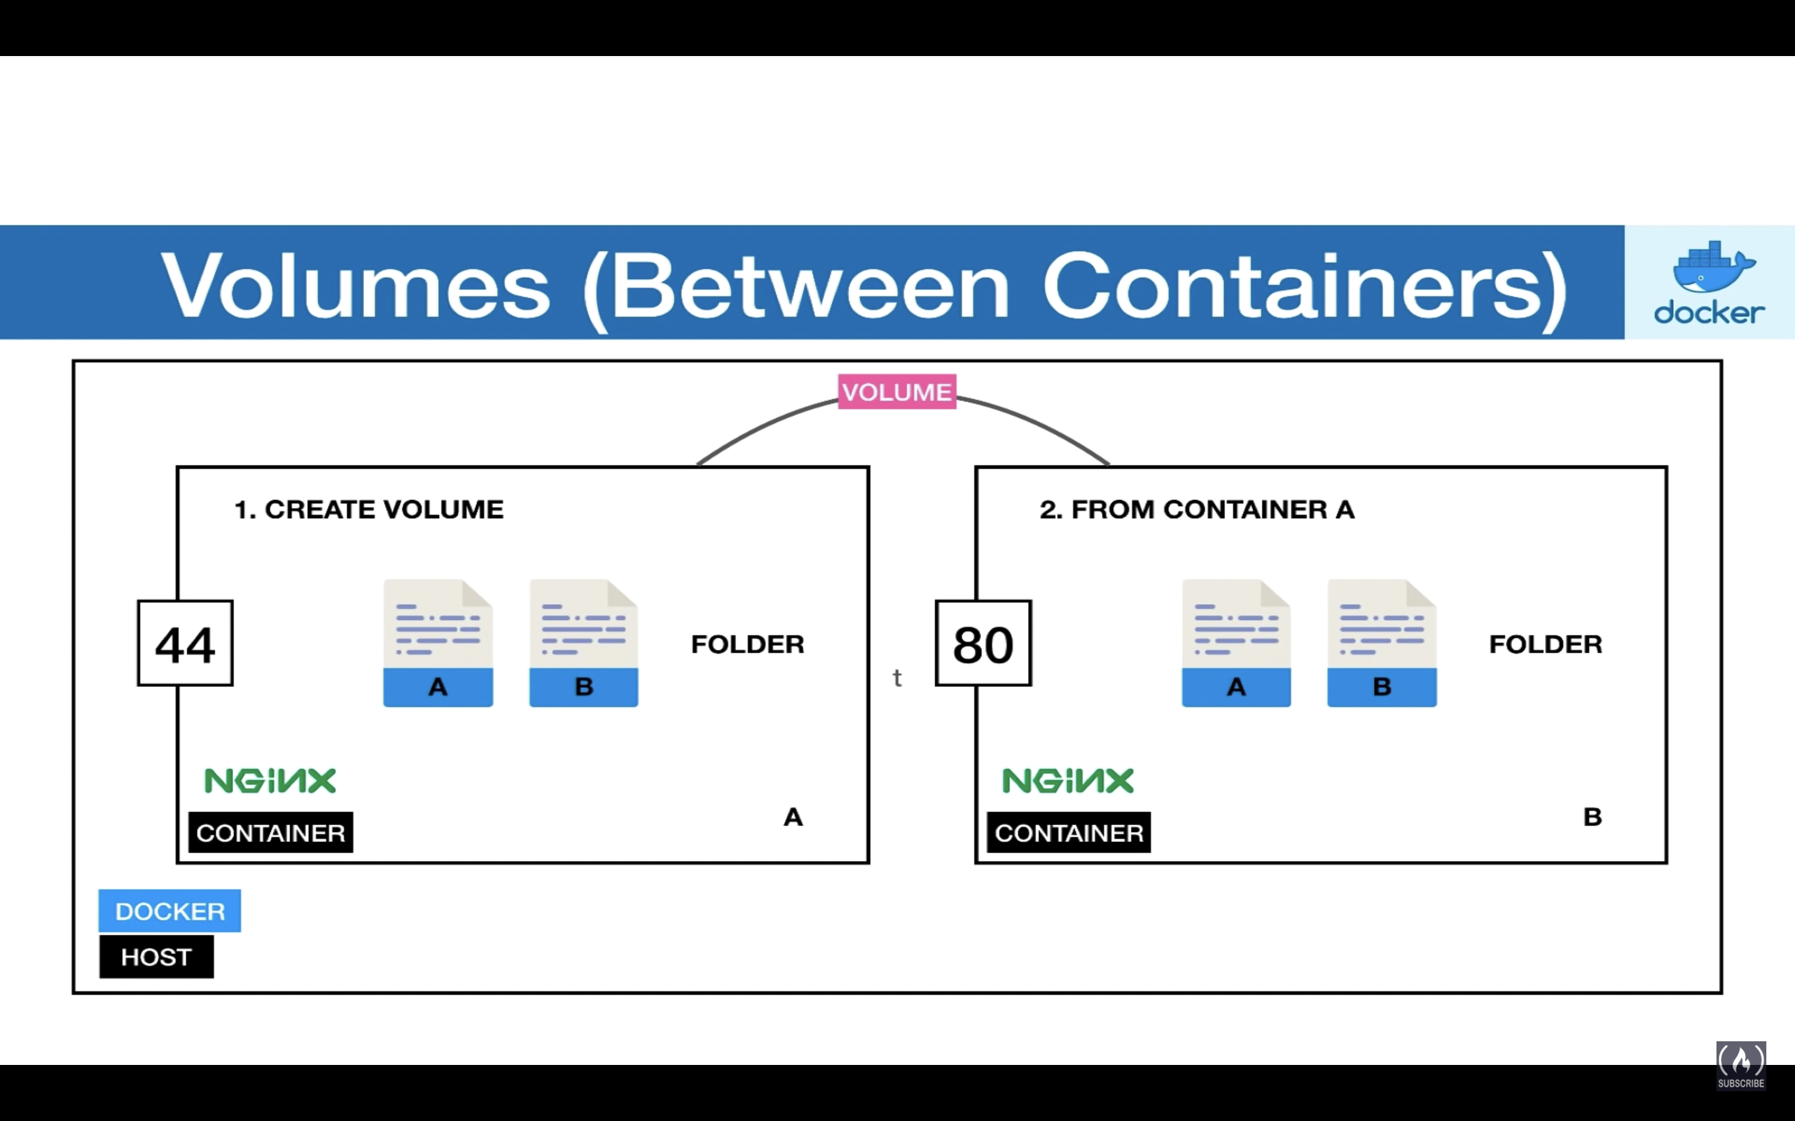

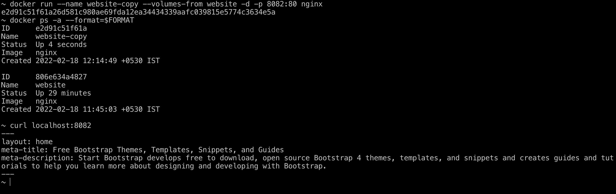

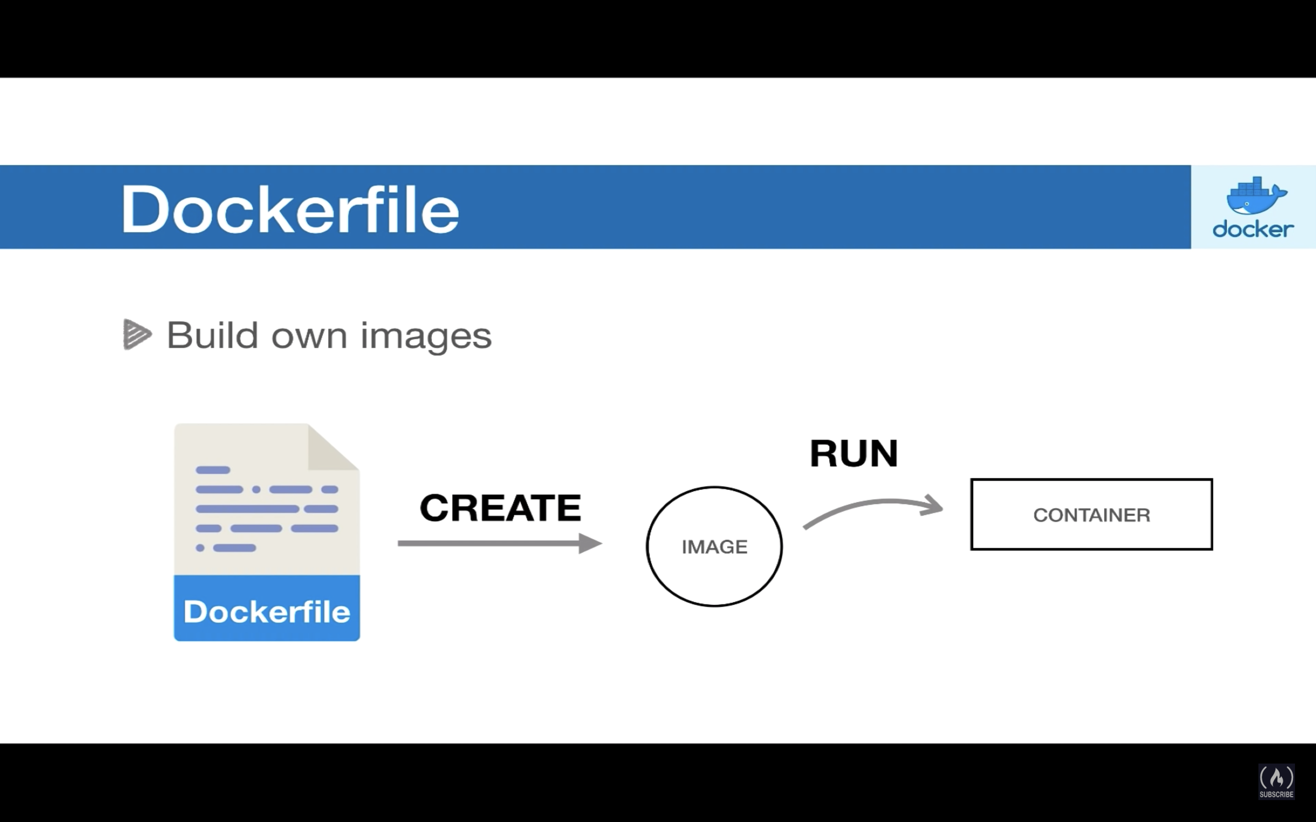

<https://docs.docker.com/engine/reference/builder/#from>

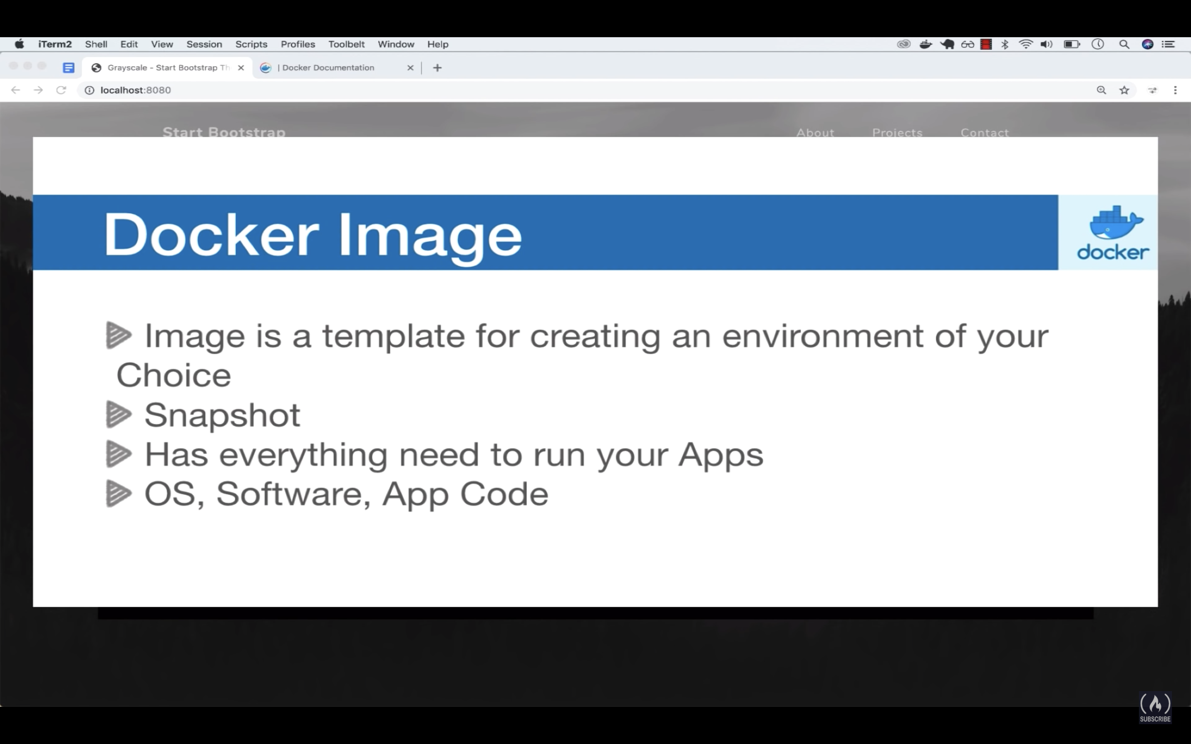

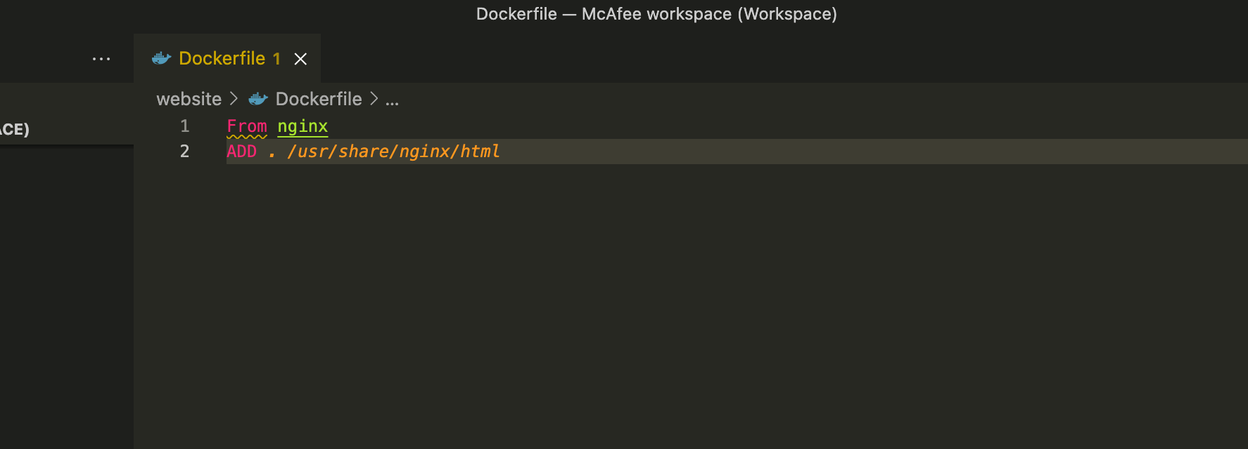

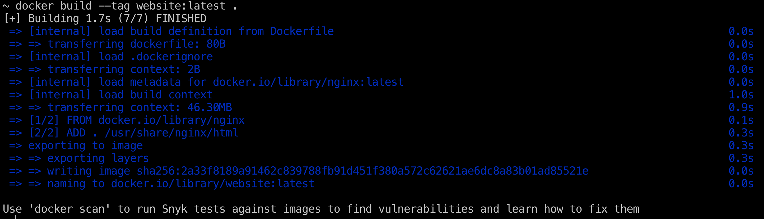

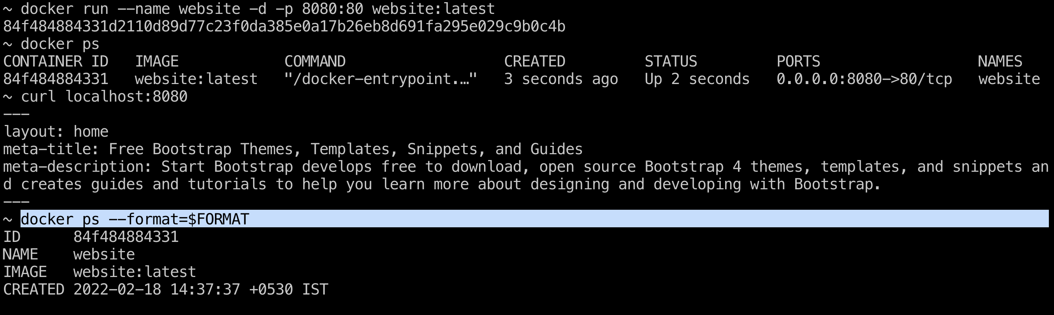

Now, we are going to configure an API in nodejs

<http://expressjs.com/en/starter/installing.html>

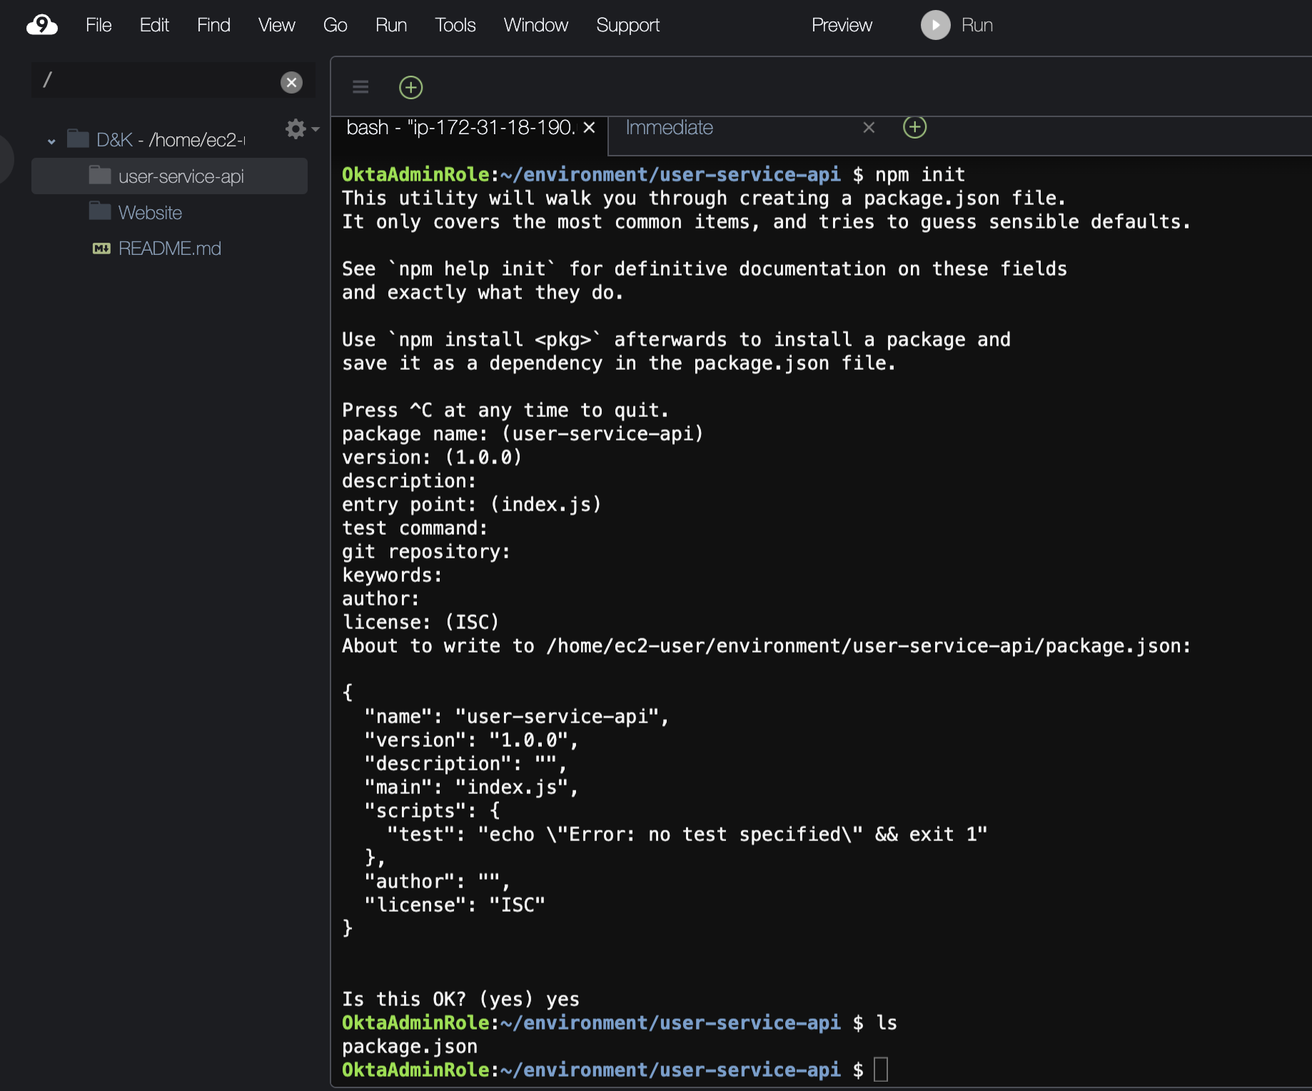

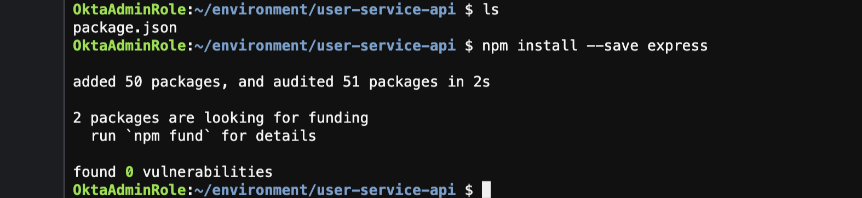

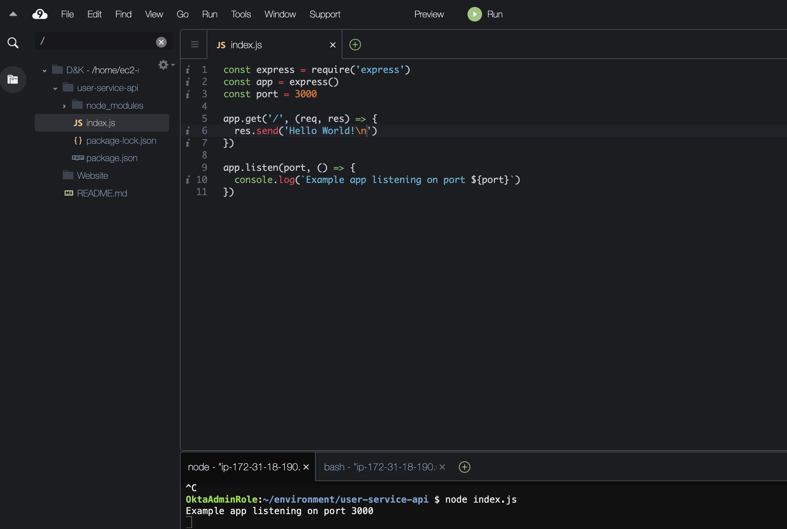

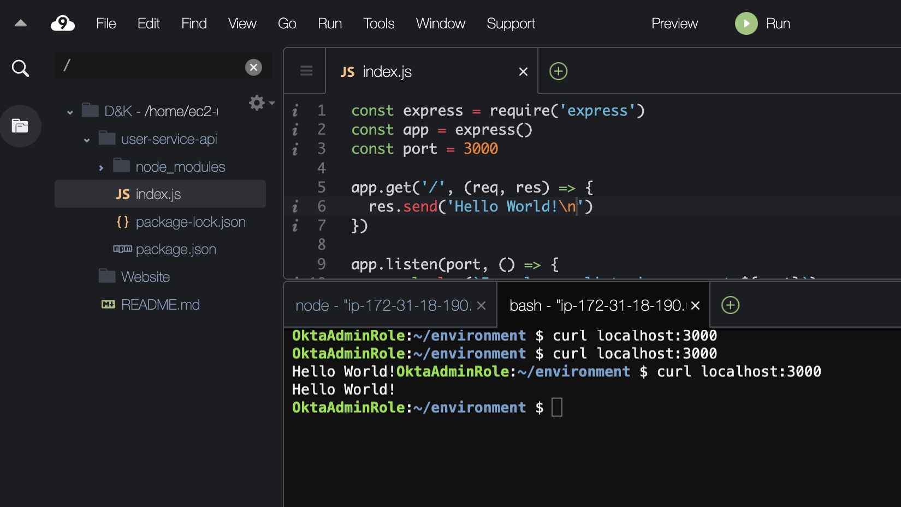

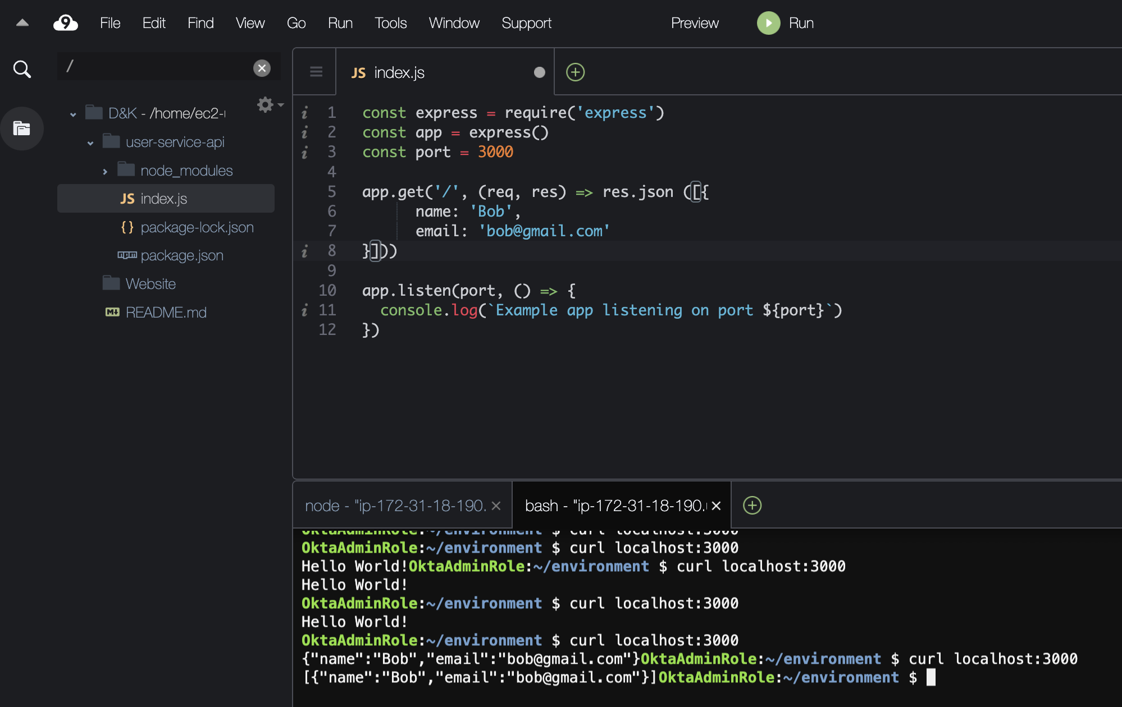

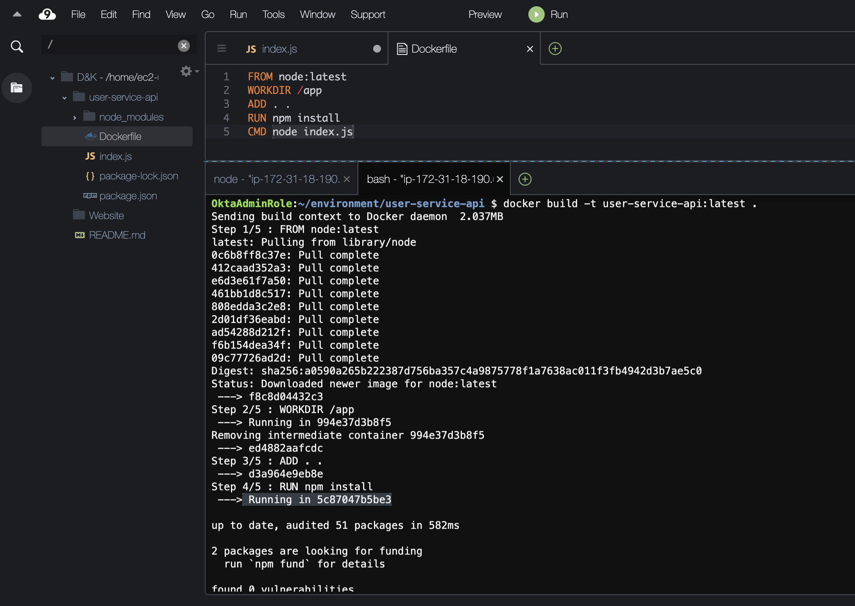

**CMD:** When the container starts what command shell be executed.

Init Containers:

* Init containers can contain utilities or custom code for setup that are not present in an app image. For example, there is no need to make an image FROM another image just to use a tool like sed, awk, python, or dig during setup.
* The application image builder and deployer roles can work independently without the need to jointly build a single app image.
* Init containers can run with a different view of the filesystem than app containers in the same Pod. Consequently, they can be given access to [Secrets](https://kubernetes.io/docs/concepts/configuration/secret/) that app containers cannot access.
* Because init containers run to completion before any app containers start, init containers offer a mechanism to block or delay app container startup until a set of preconditions are met. Once preconditions are met, all of the app containers in a Pod can start in parallel.
* Init containers can securely run utilities or custom code that would otherwise make an app container image less secure. By keeping unnecessary tools separate you can limit the attack surface of your app container image.

<https://kubernetes.io/docs/concepts/workloads/pods/init-containers/#init-containers-in-use>

SideCar Container:

<https://kubernetes.io/docs/concepts/cluster-administration/logging/#streaming-sidecar-container>

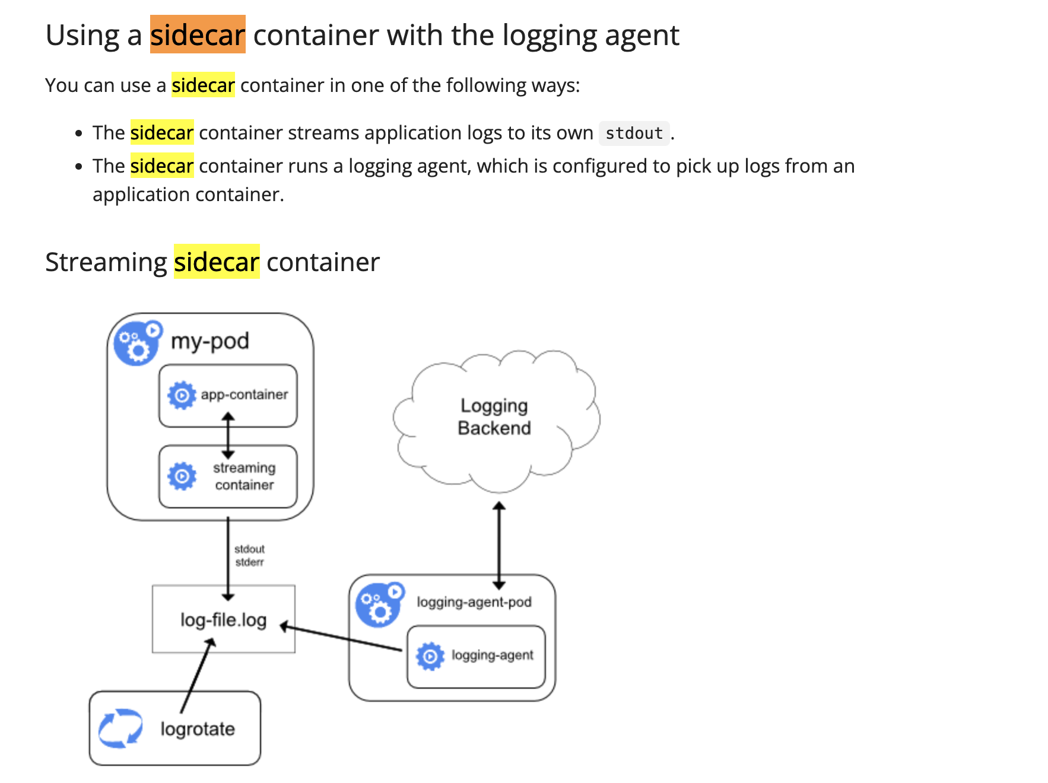

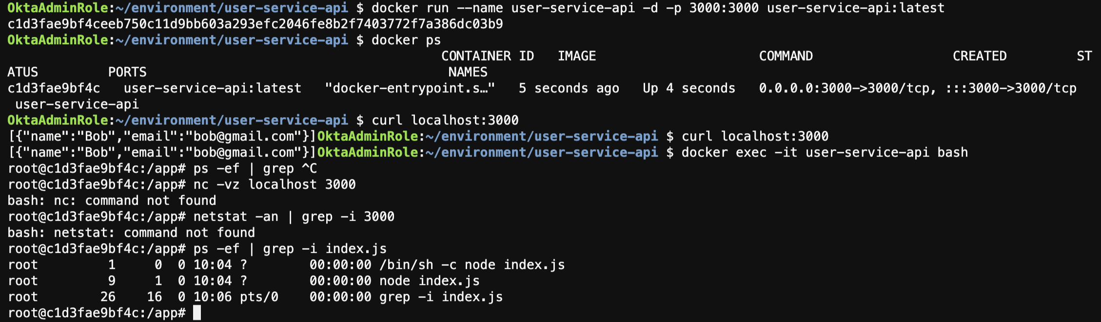

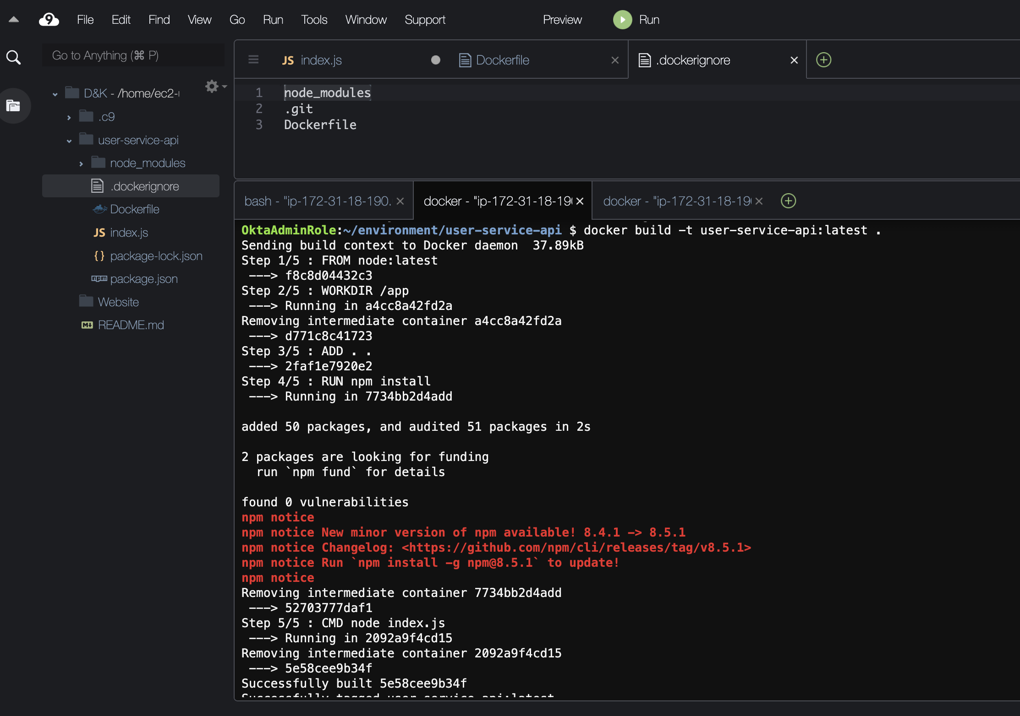

Caching & Layers

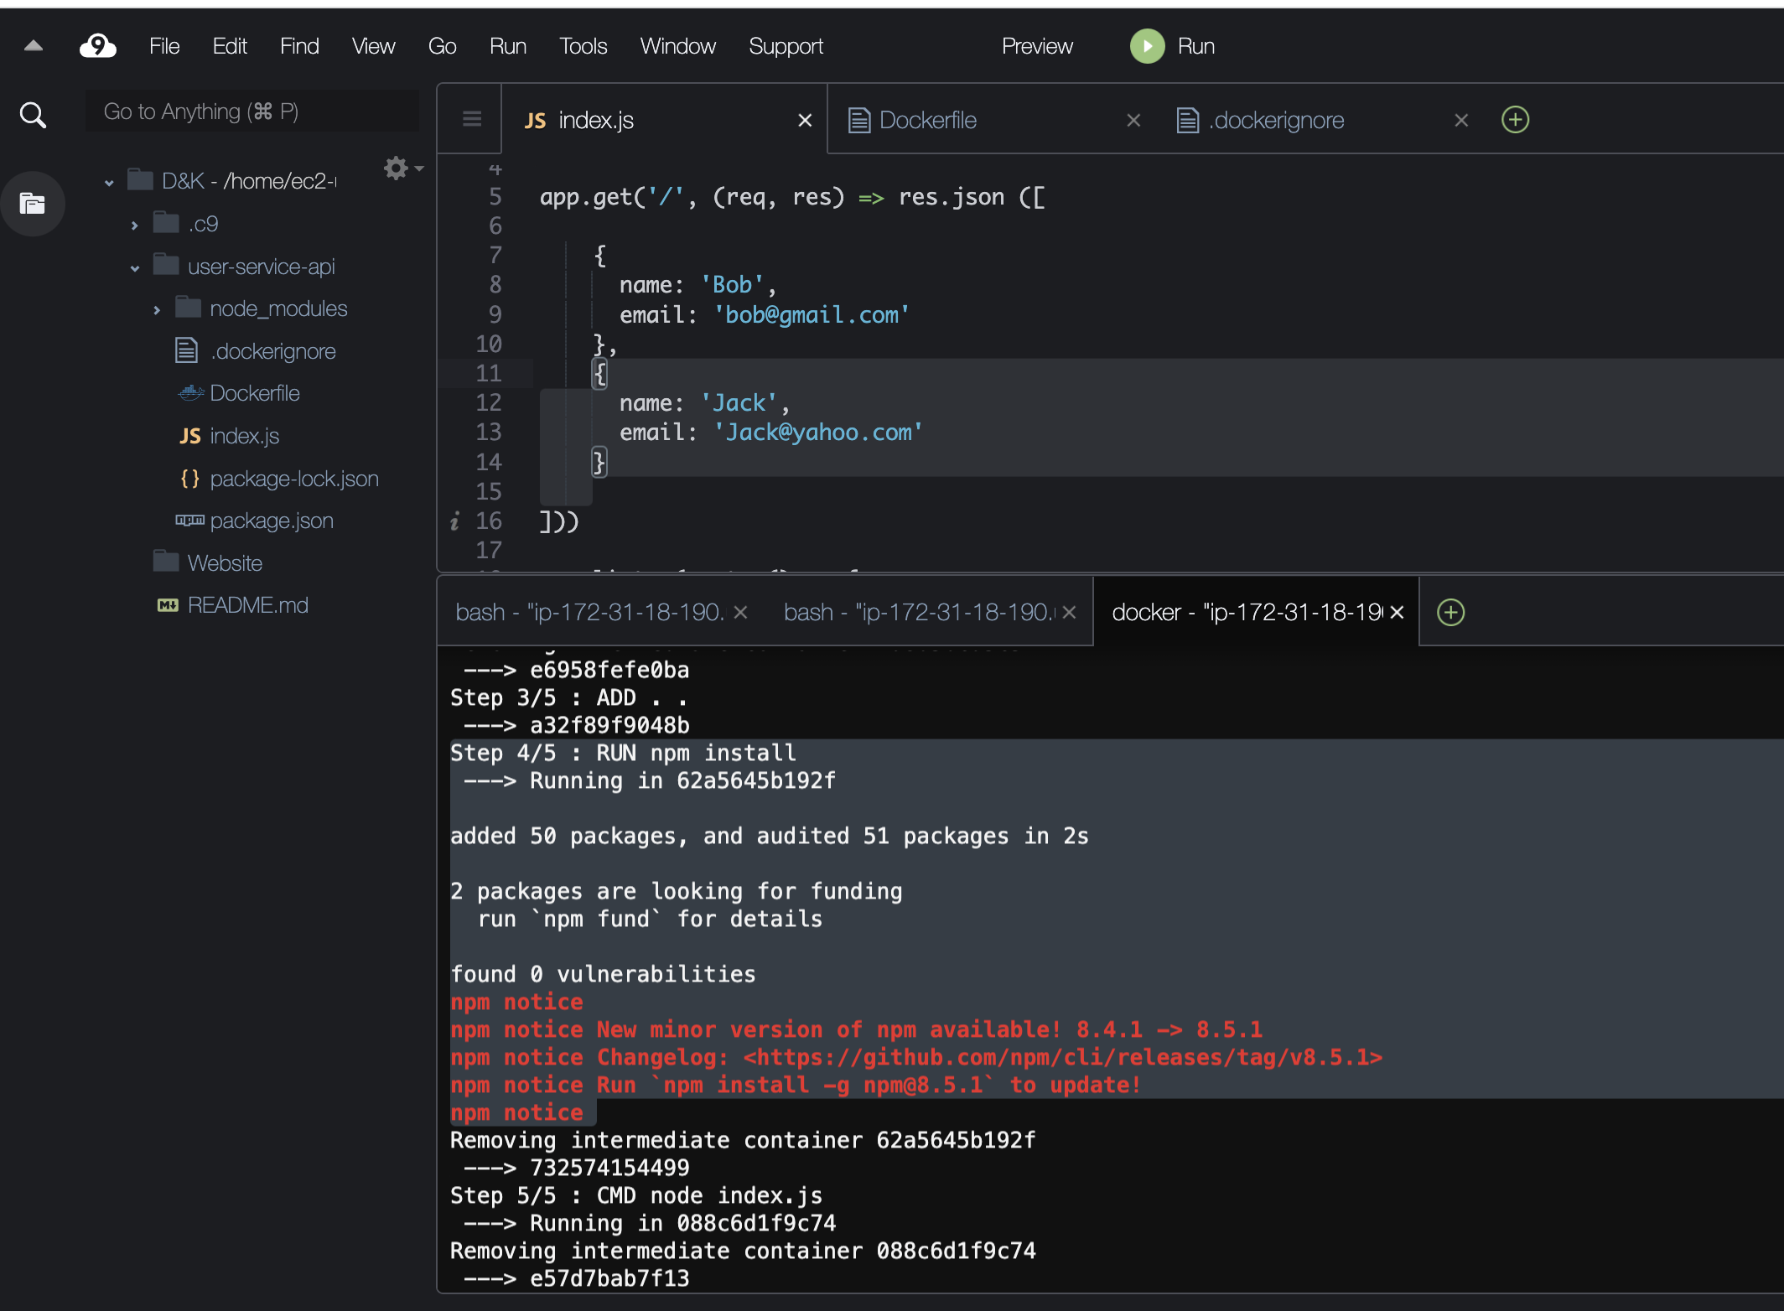

This is only when we are changing the code the image building is taking so much of time. So we are tweaking the dockerfile

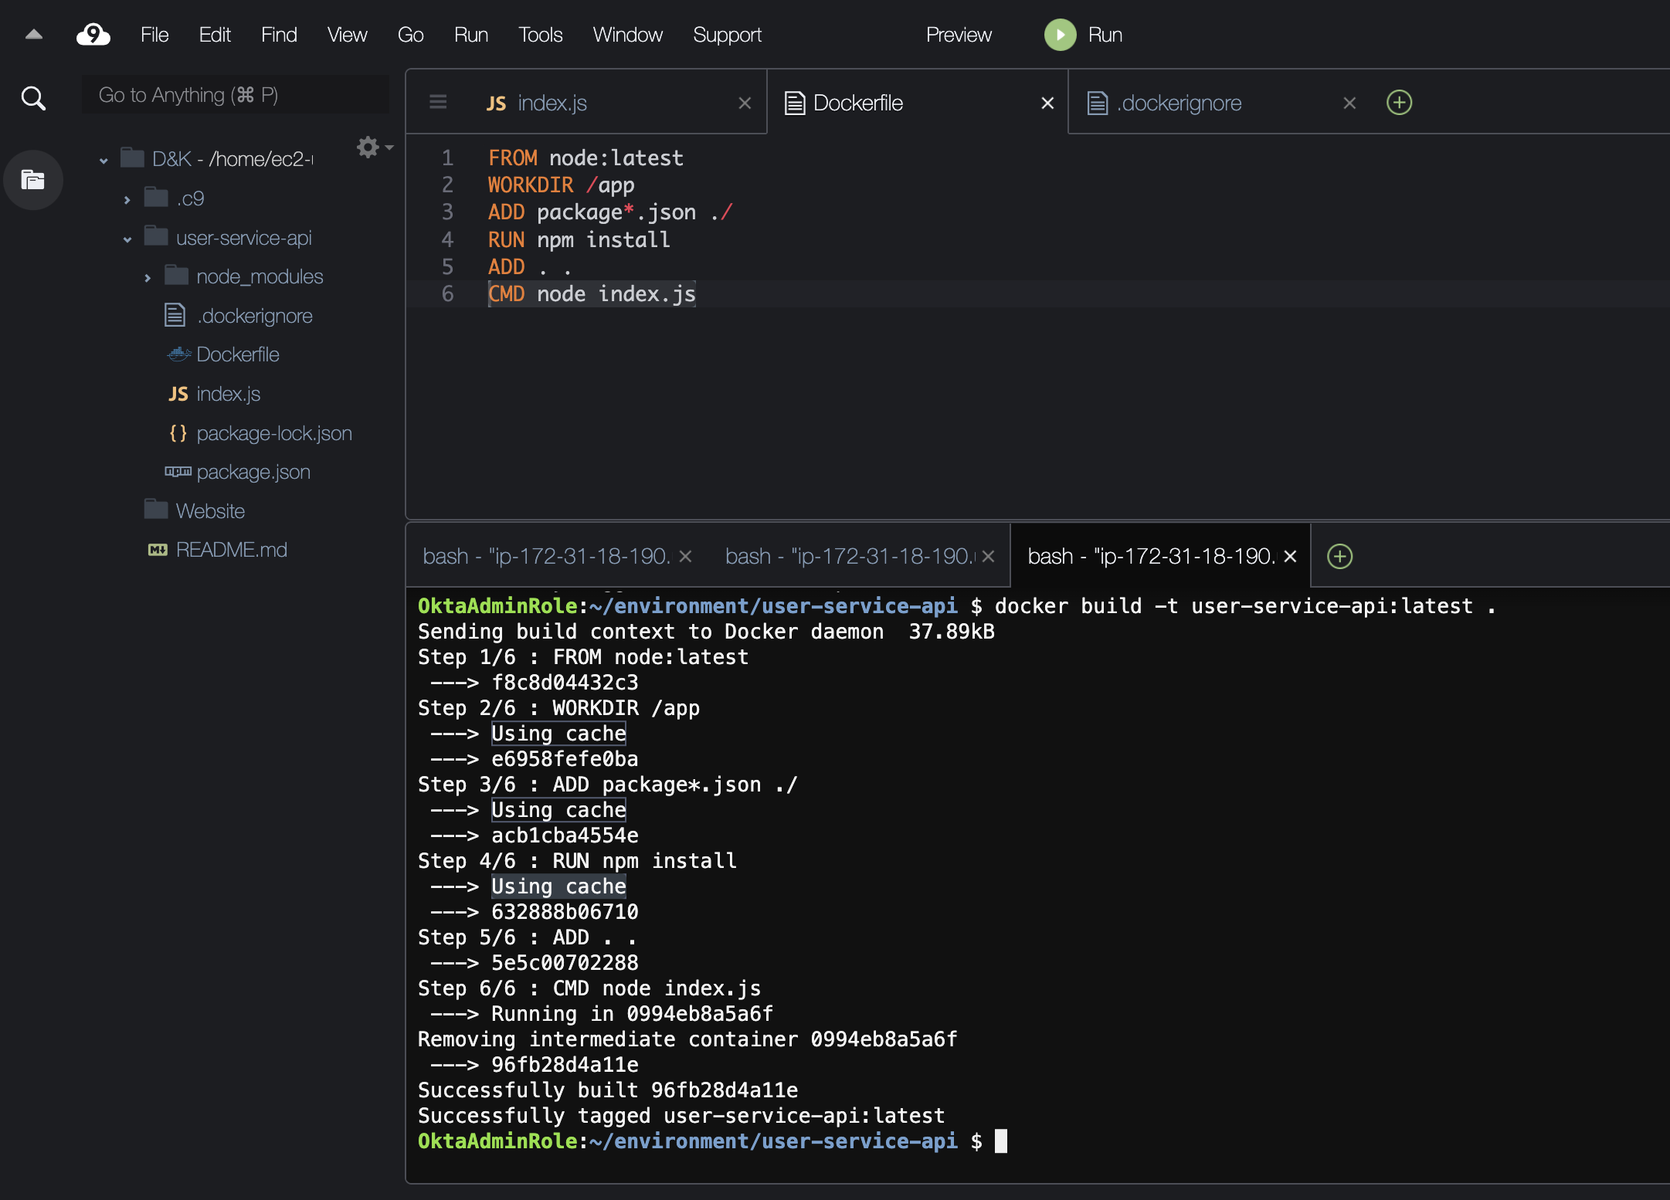

<https://alpinelinux.org/>

Image Size Compression

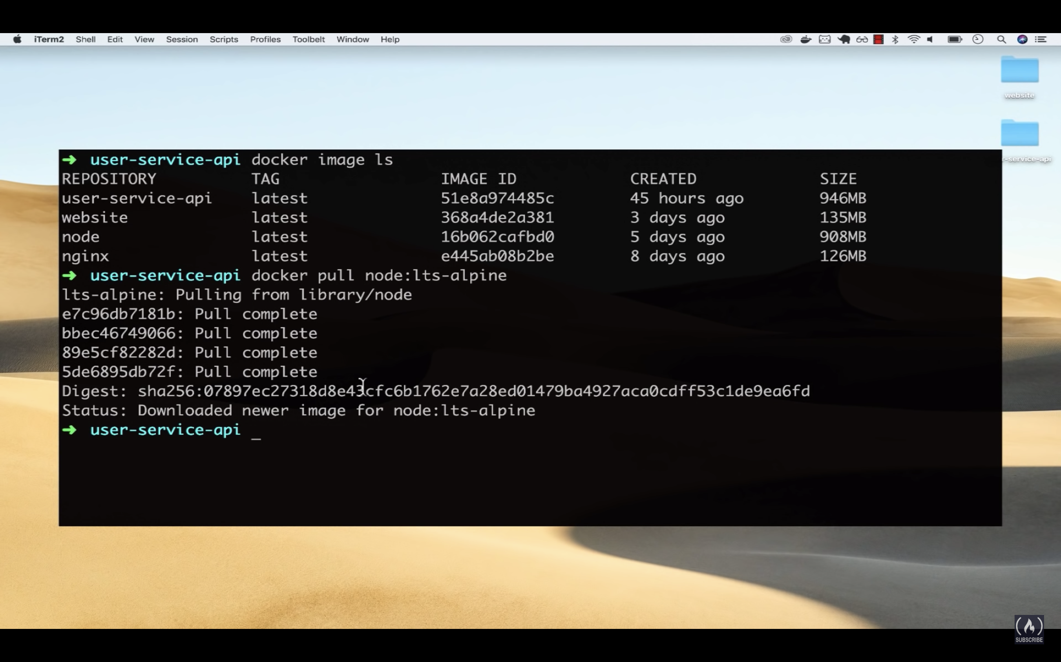

**Node:lts- alpine** where lts signifies latest tag

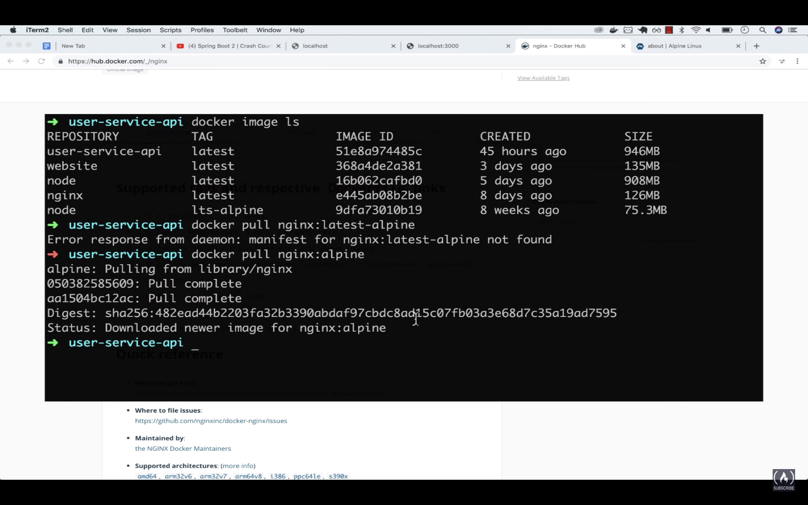

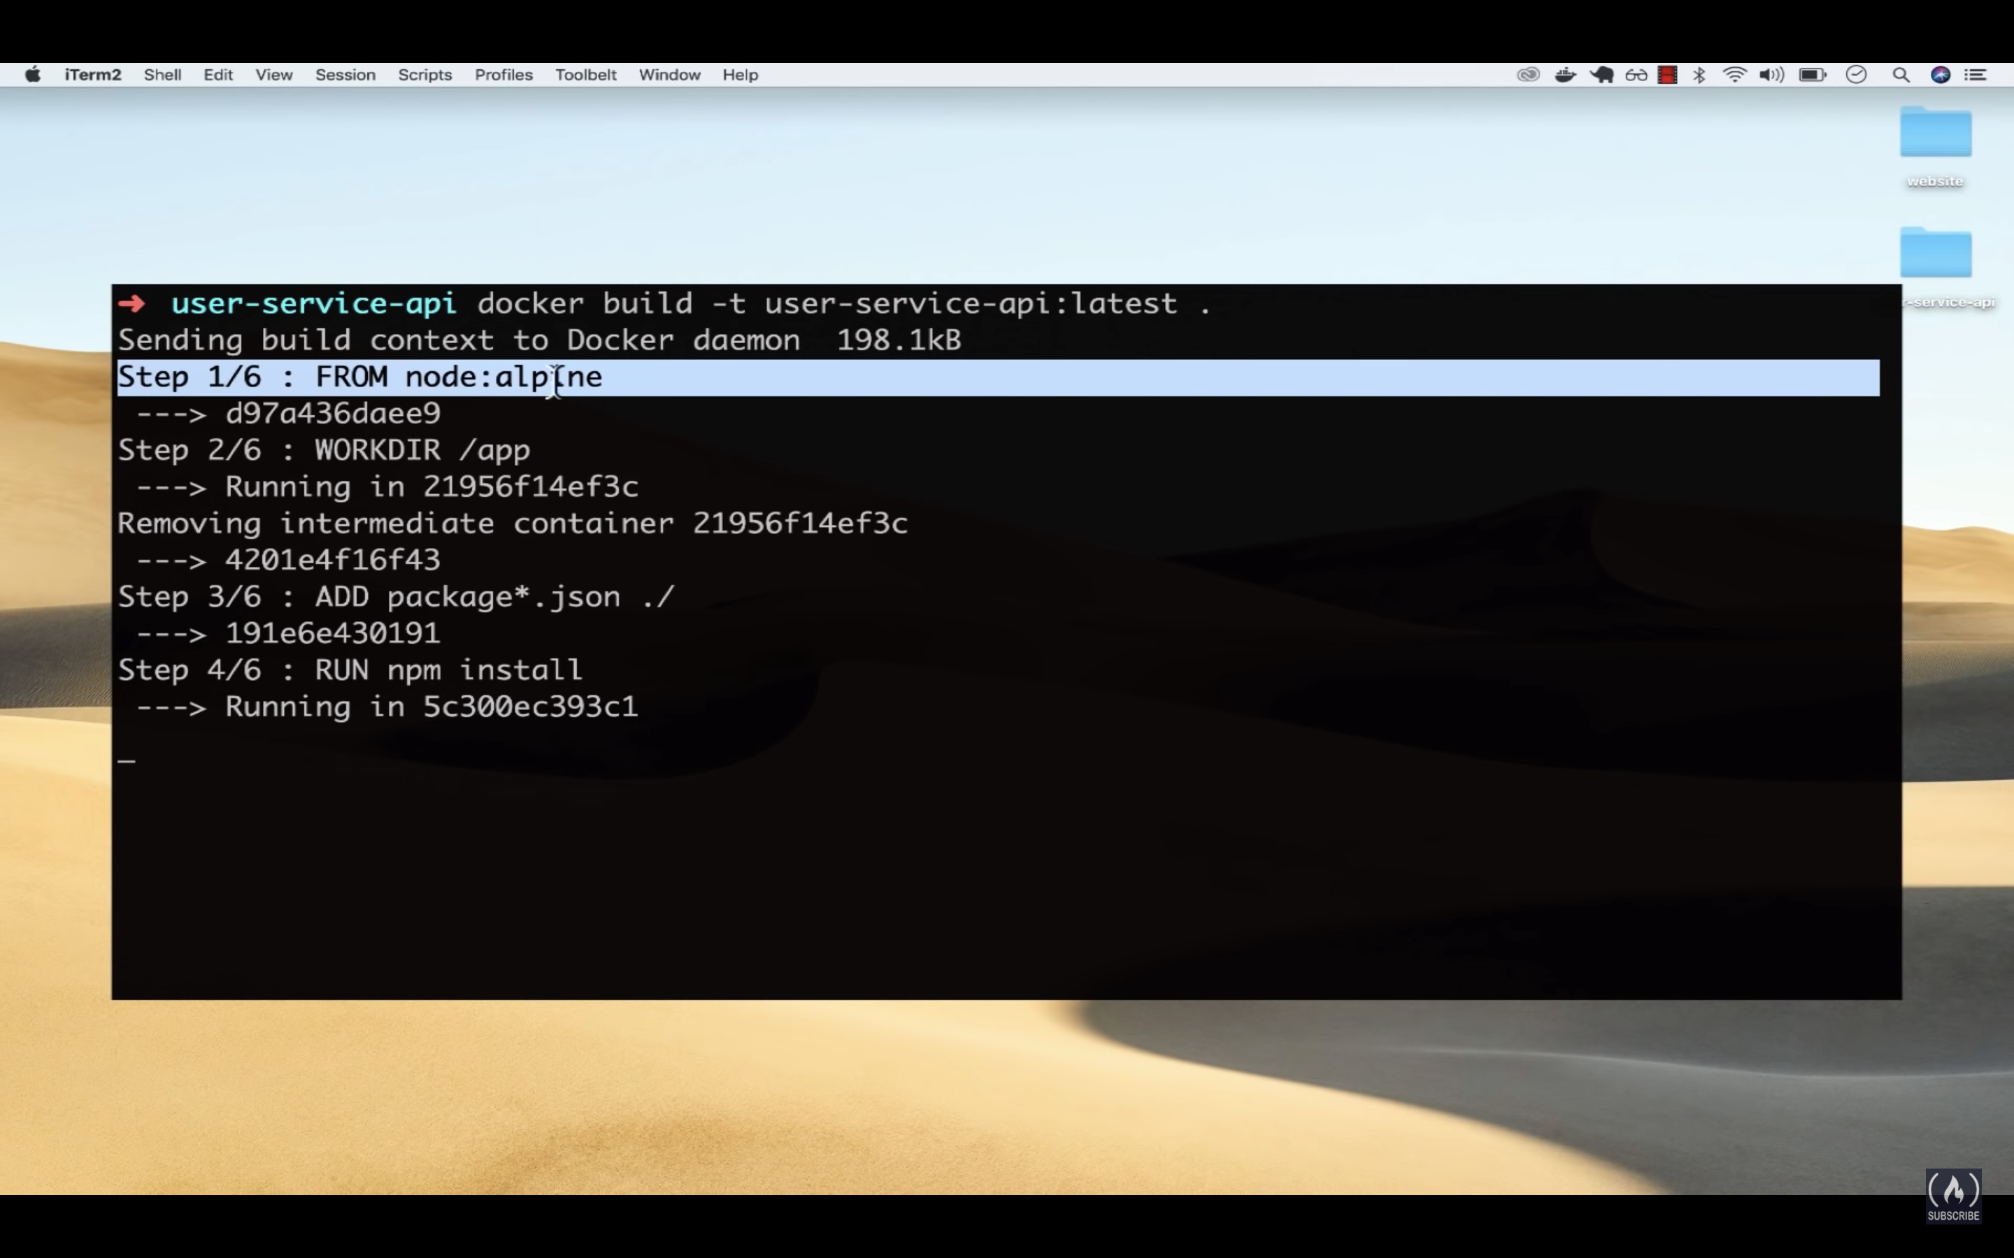

This time all the layers are going to take time because, the first layer has changed and it’s going to recalculating again.

If we build the same image again, it’s superfast as it’s fetching everything from the cache.

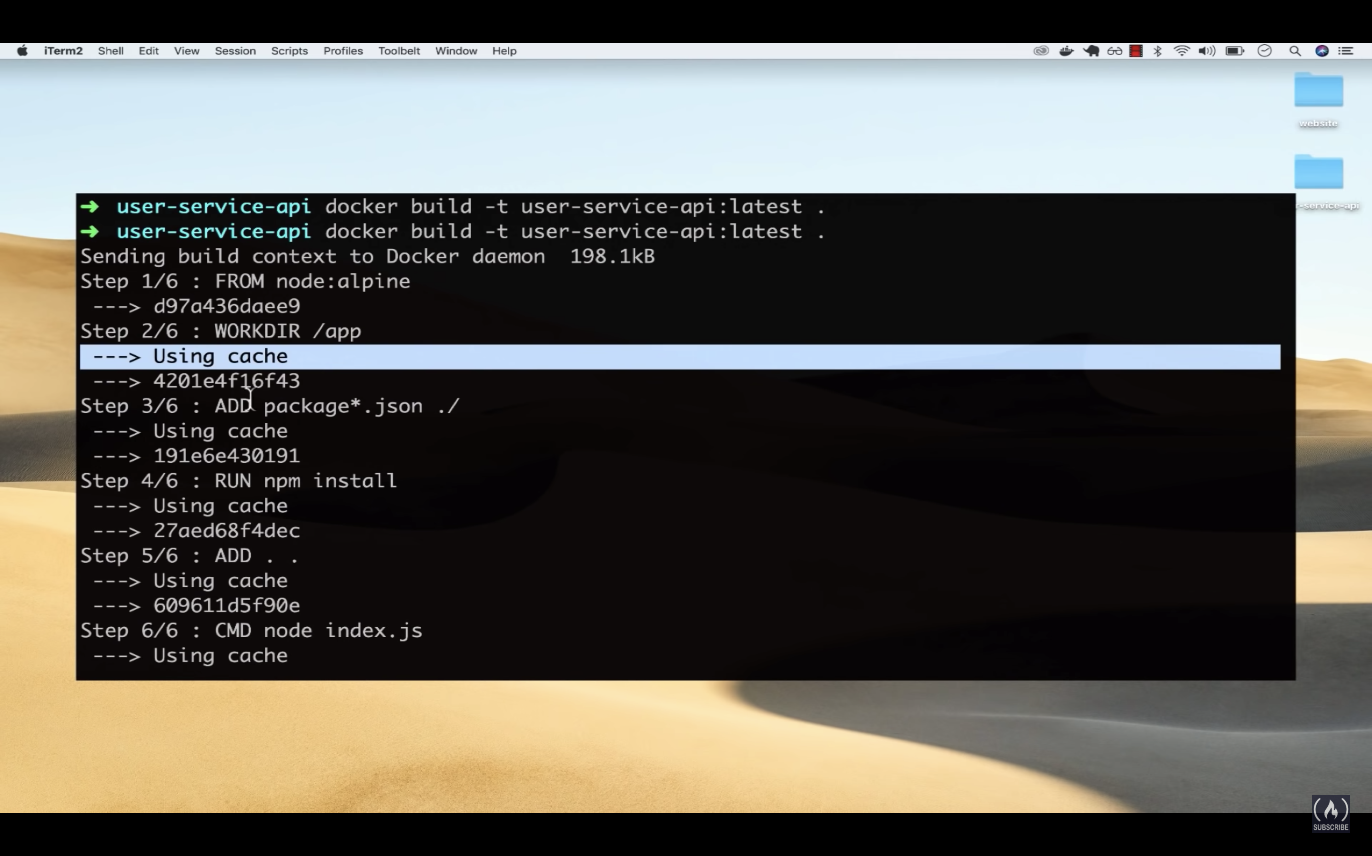

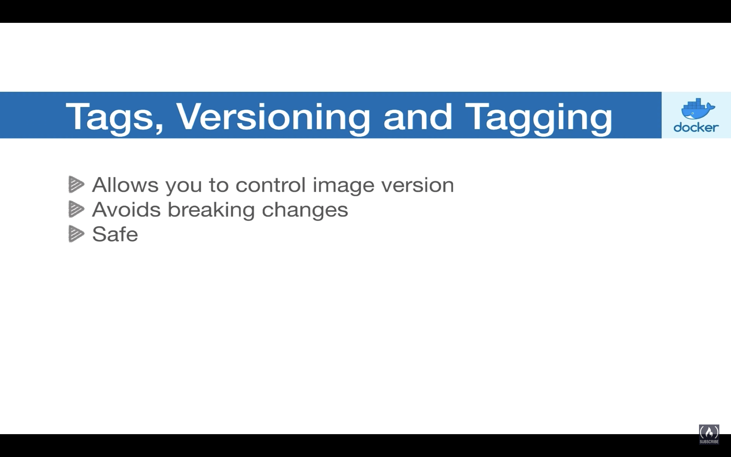

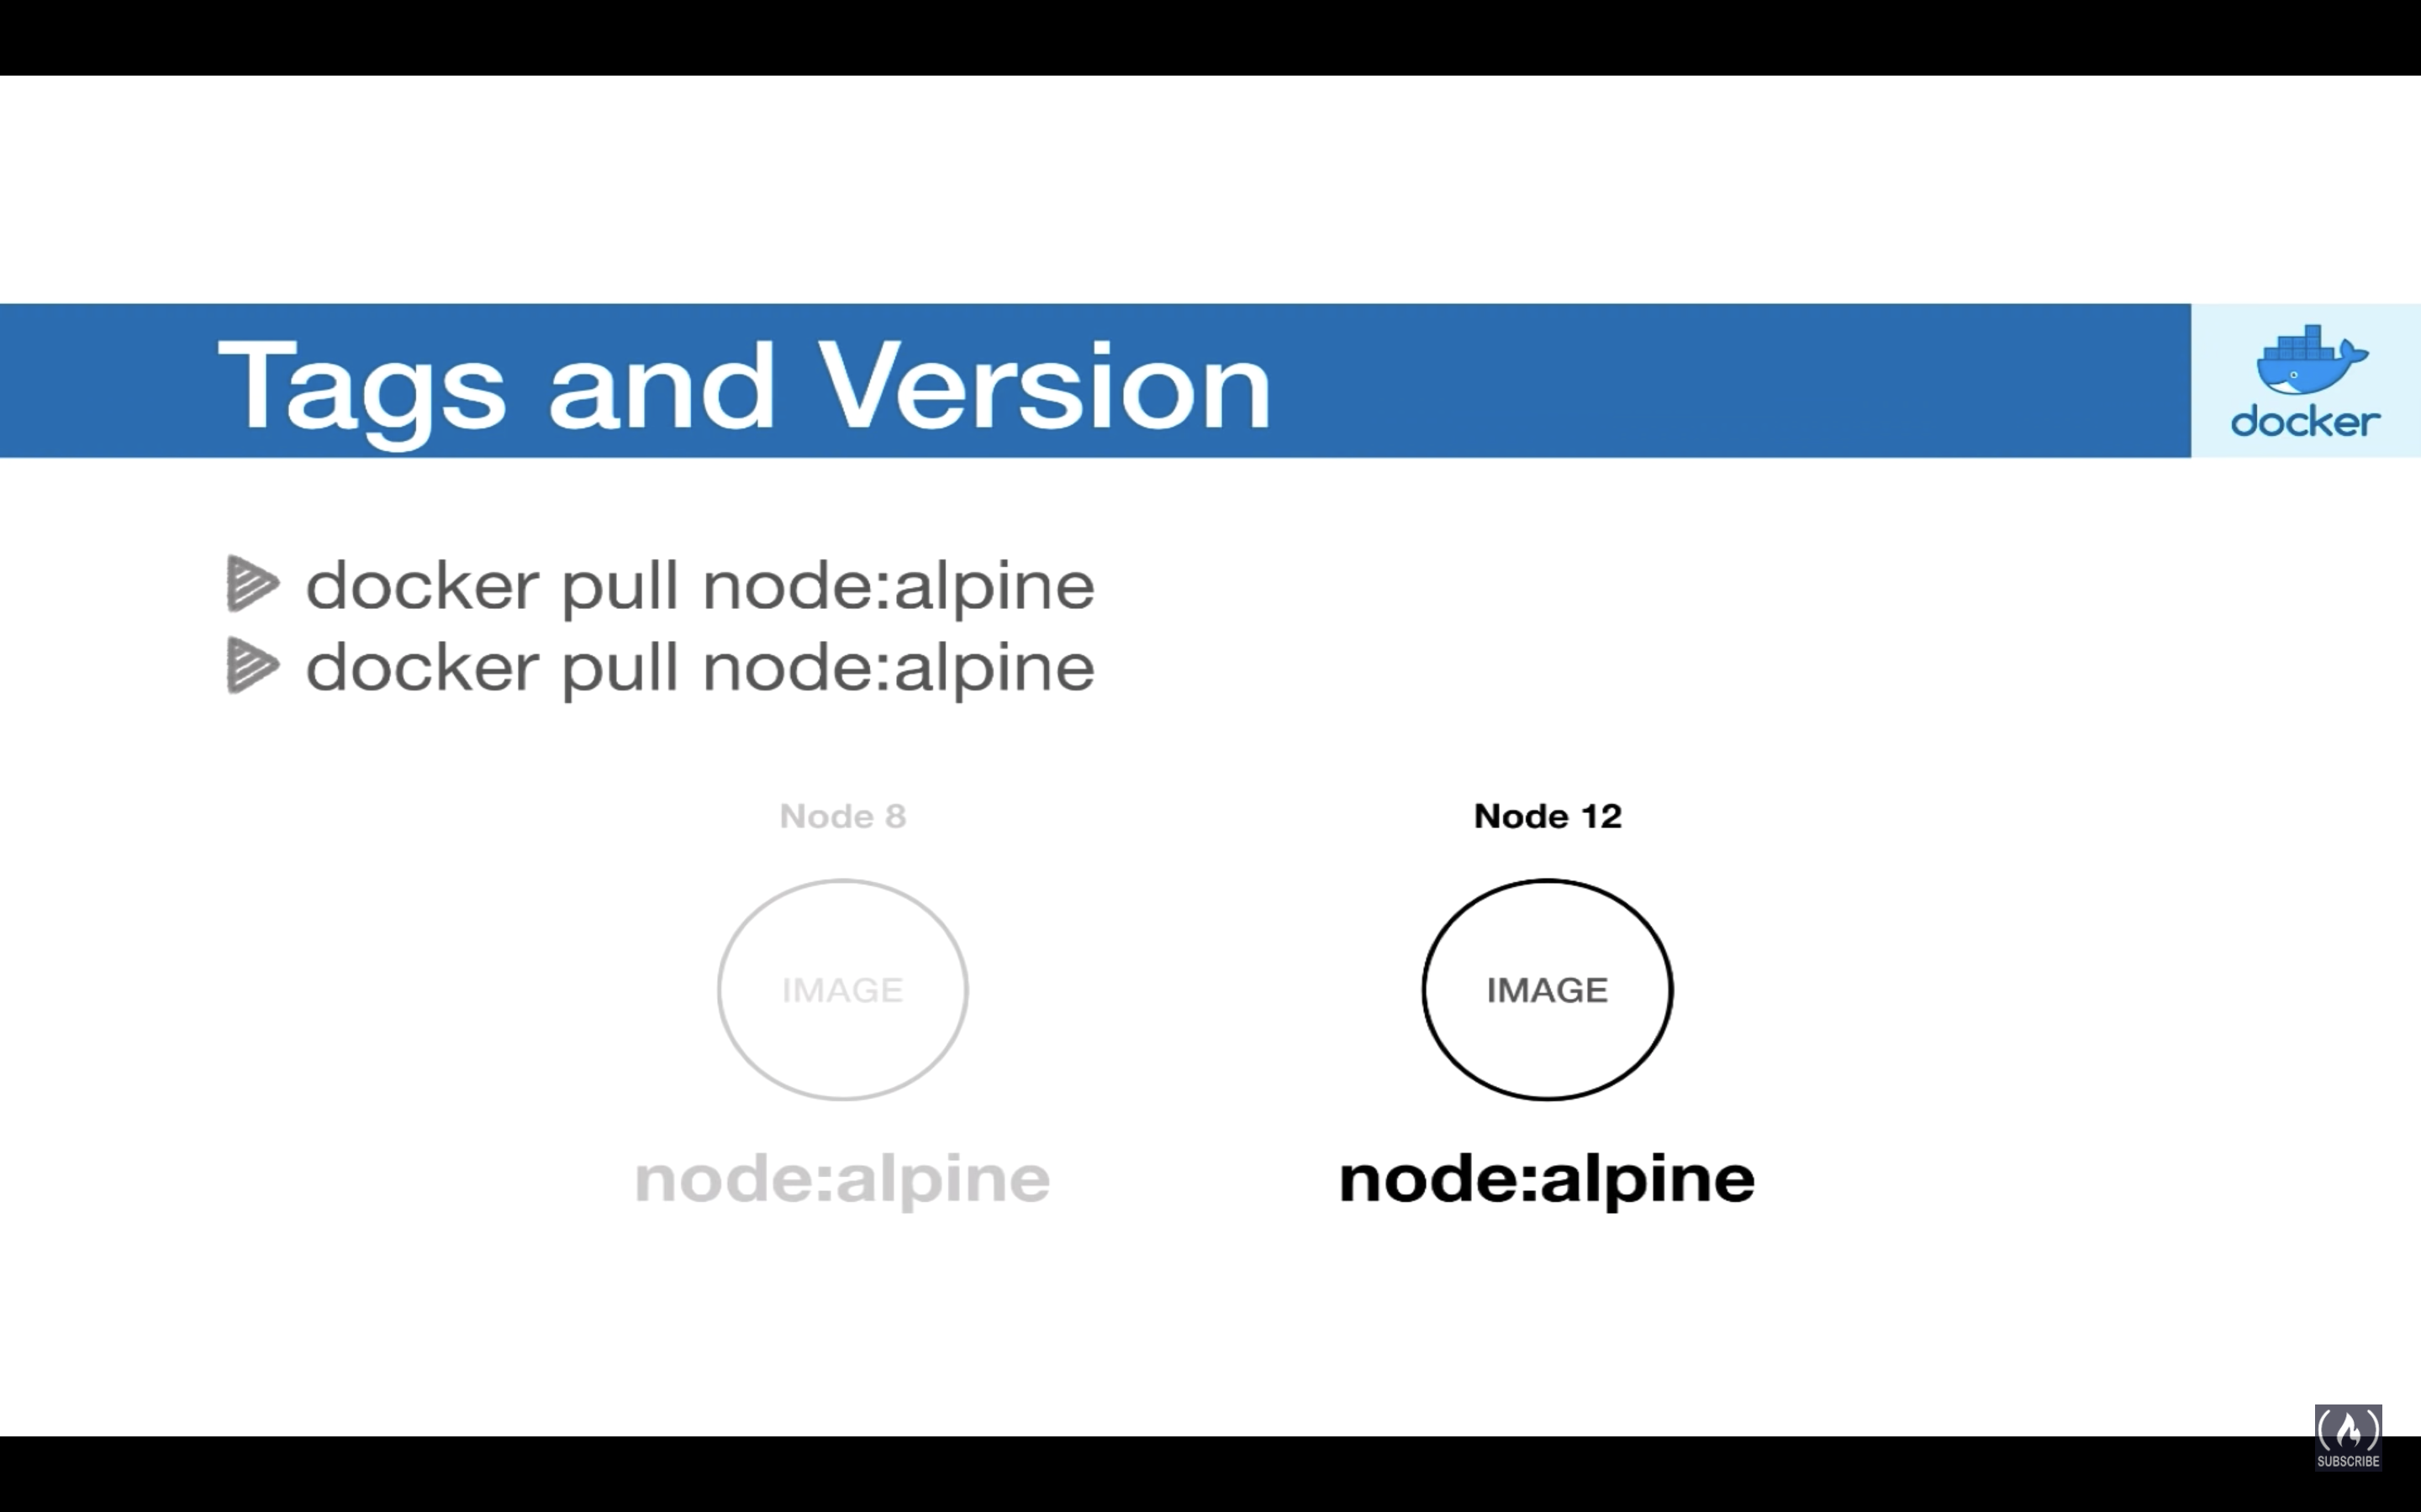

Alpine version is the smallest Linux distribution

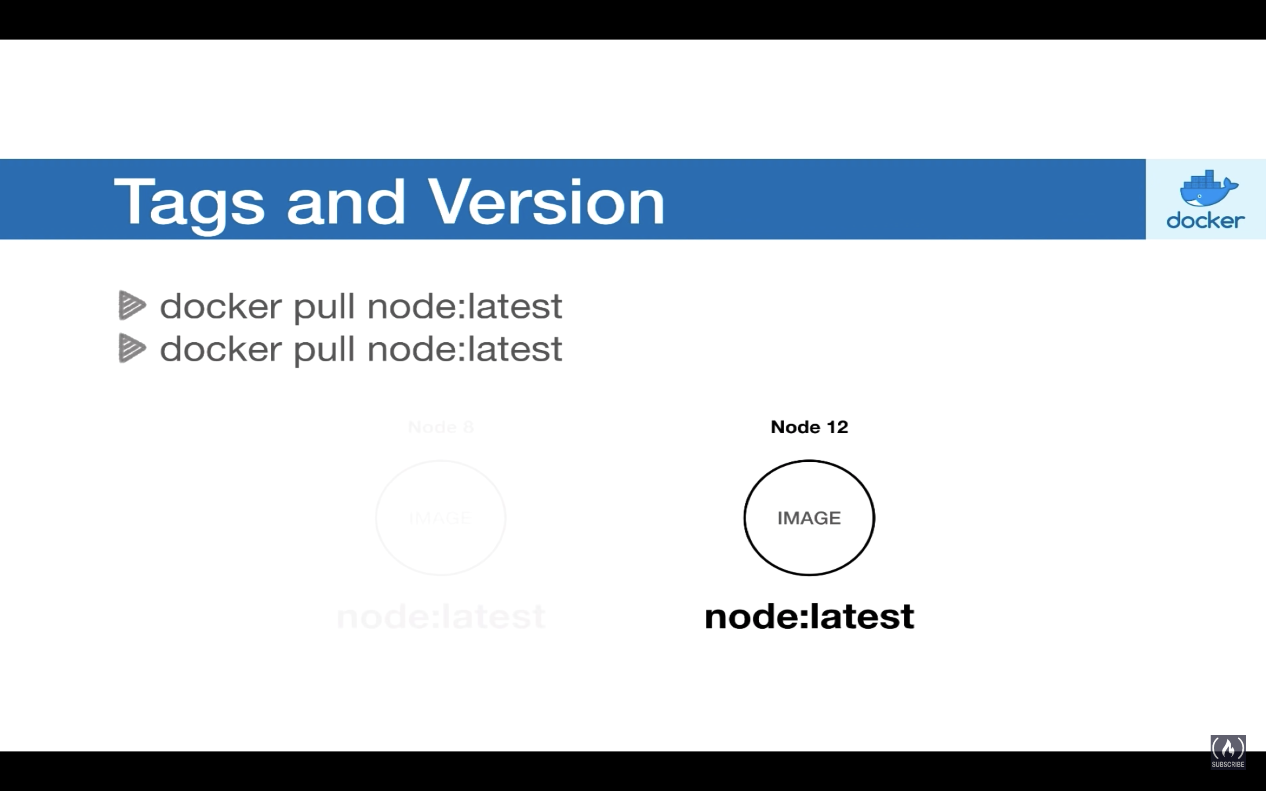

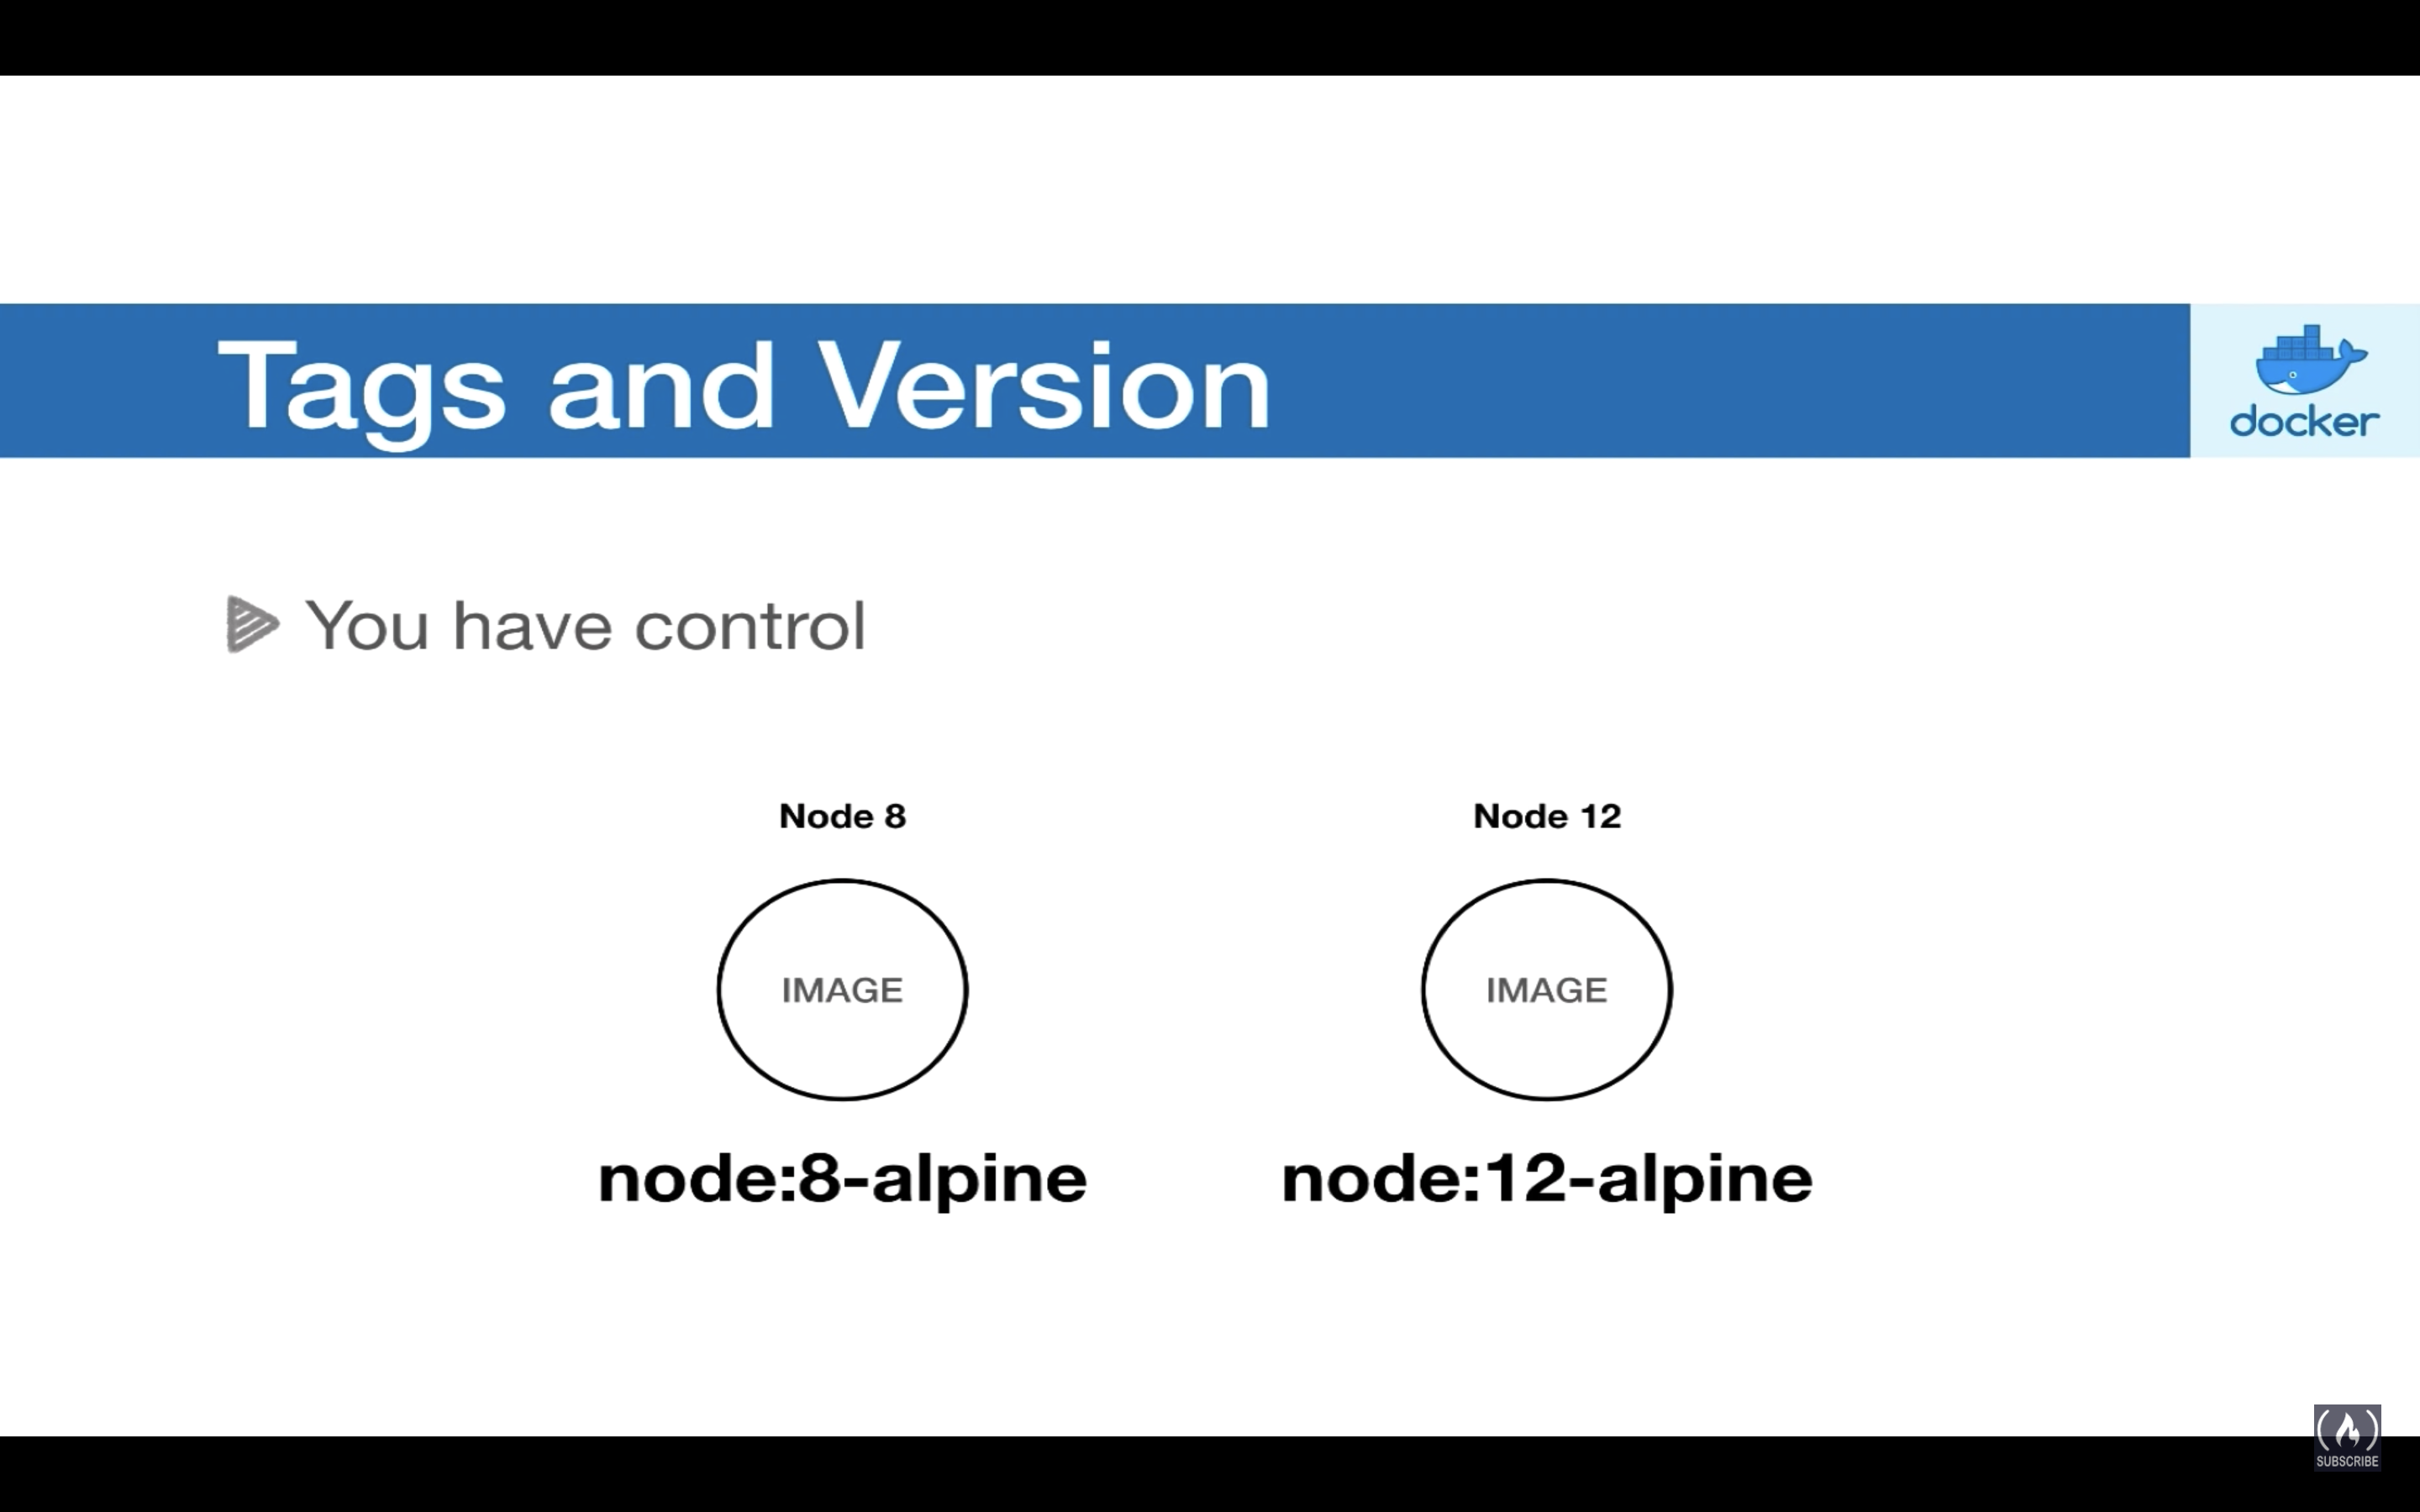

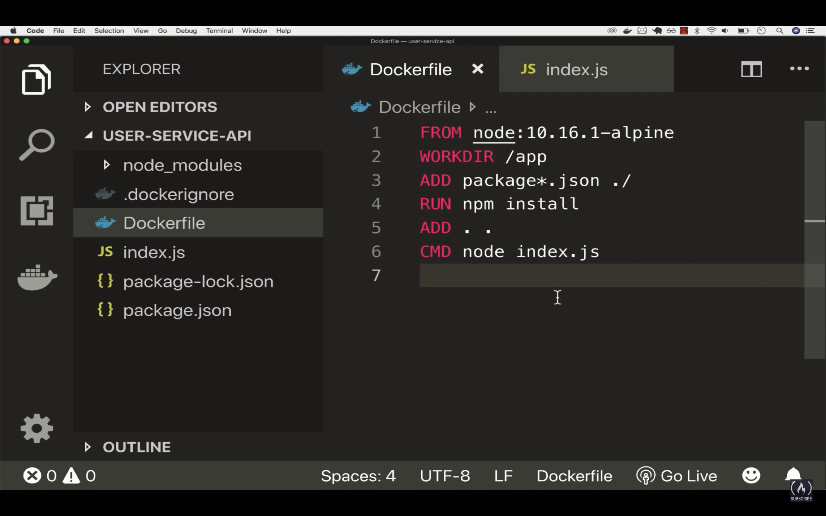

So when you use different image but mark it with latest tag it always overwrite the image tags and repository and hence you see the older images will be marked as <NONE> in repo, tags sections.

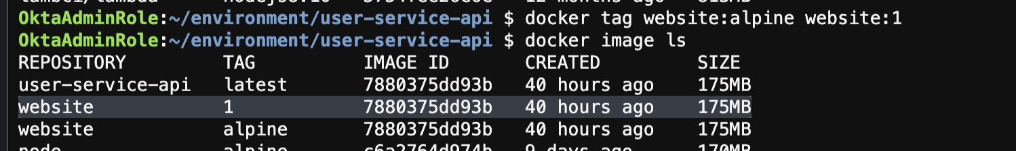

Now we have both alpine as well 1 Tag.

Now modify some code and build a new image with 2 tag

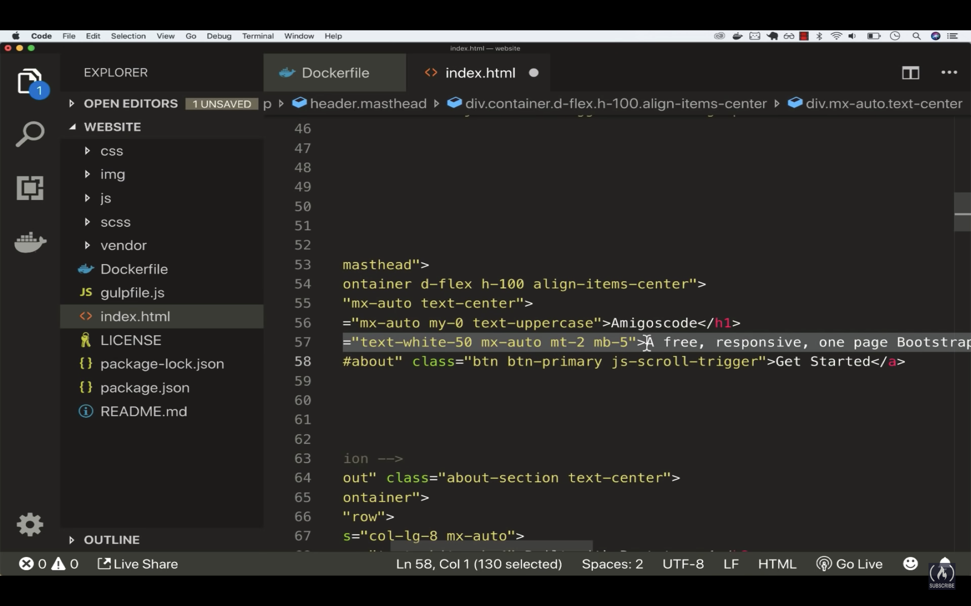

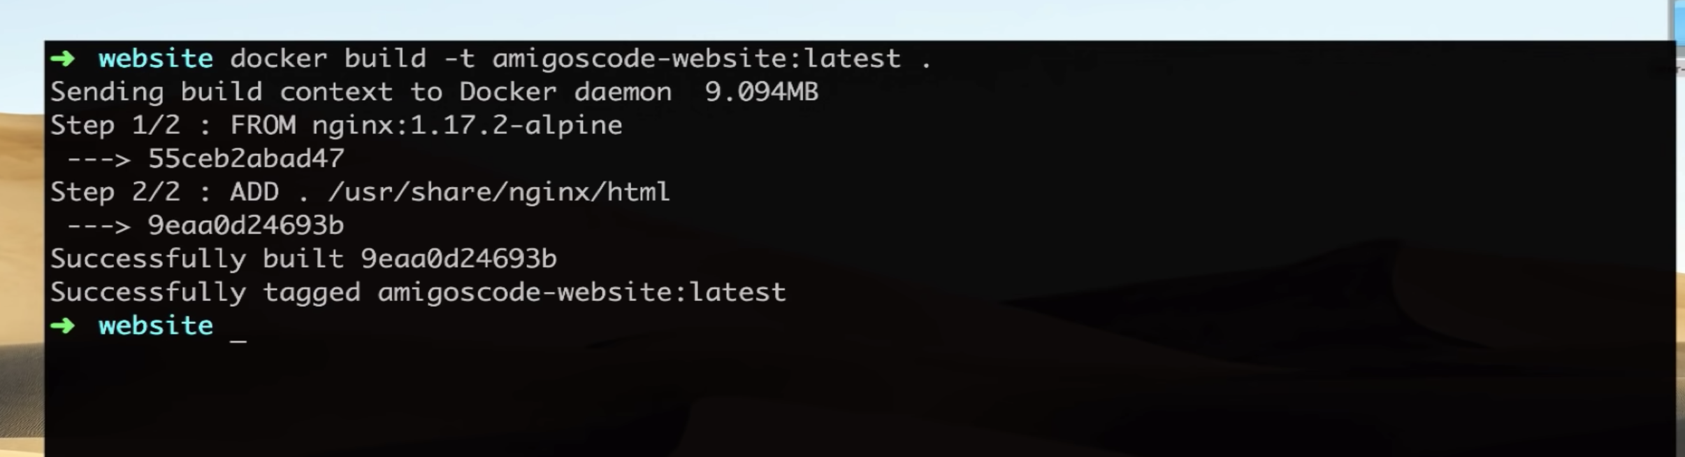

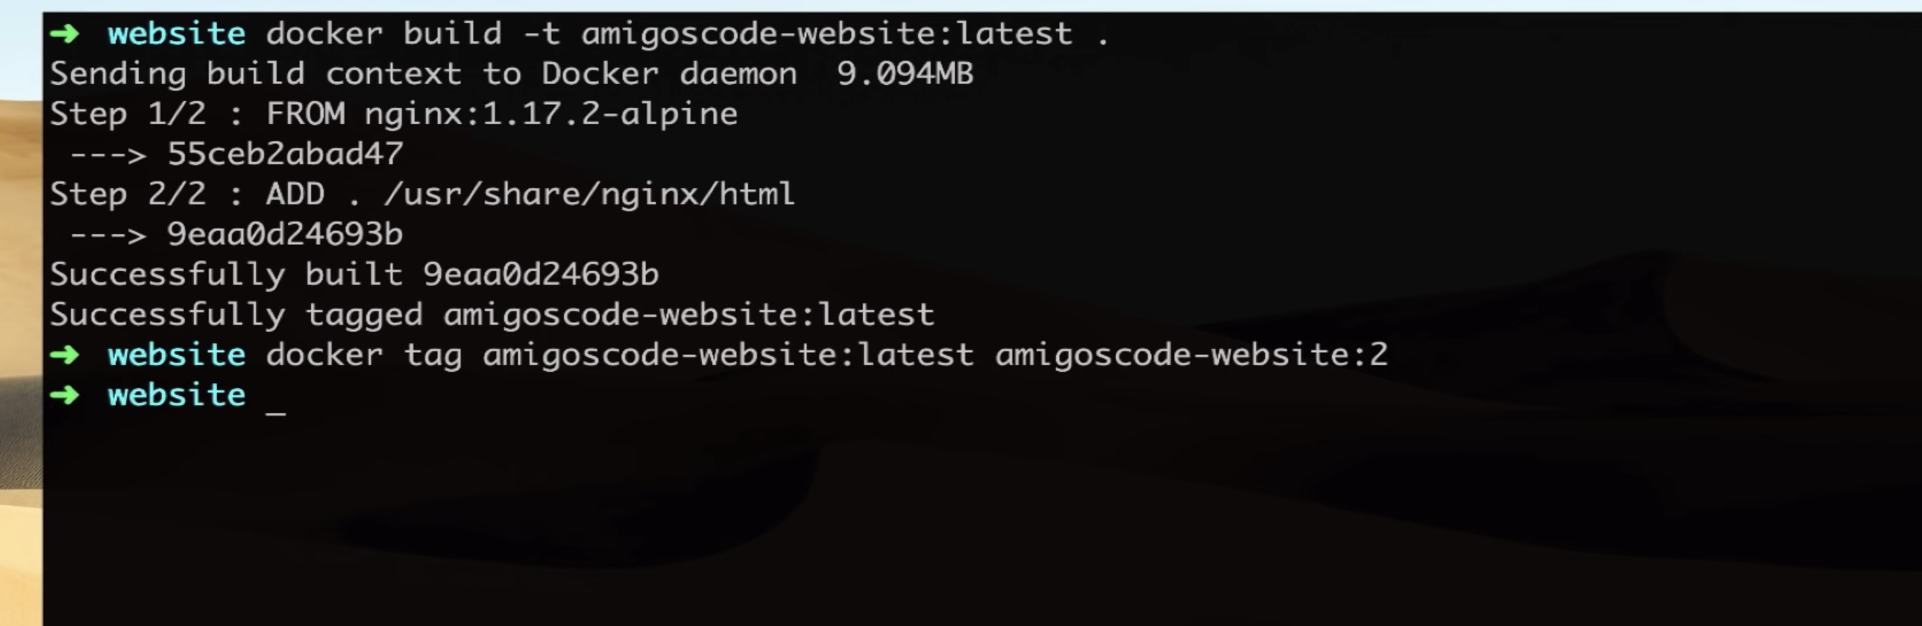

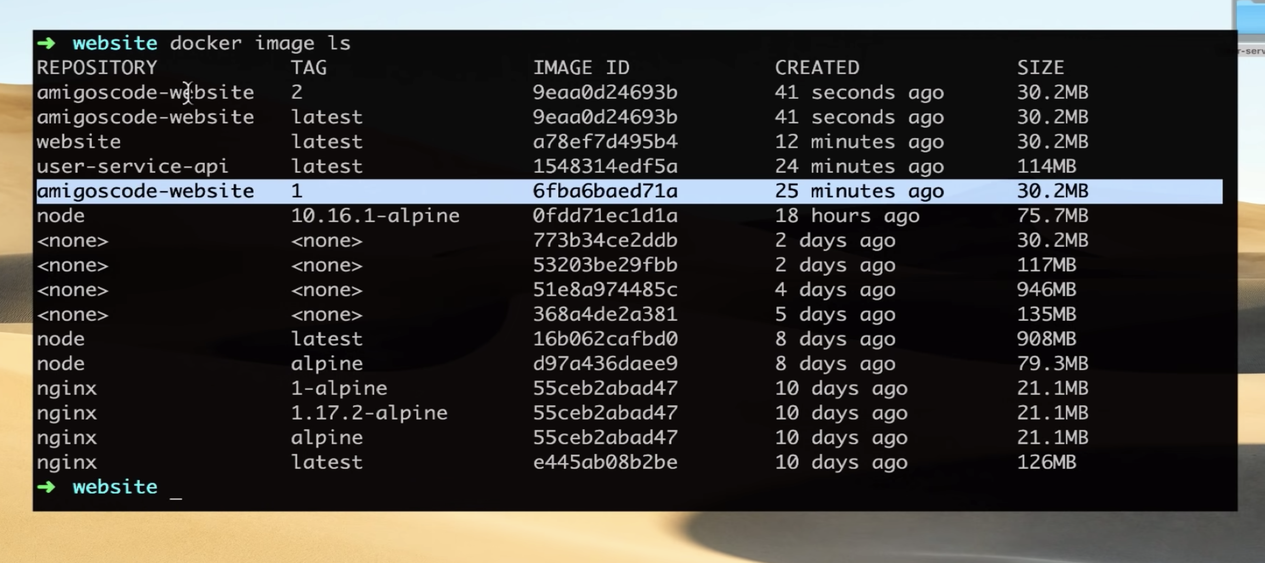

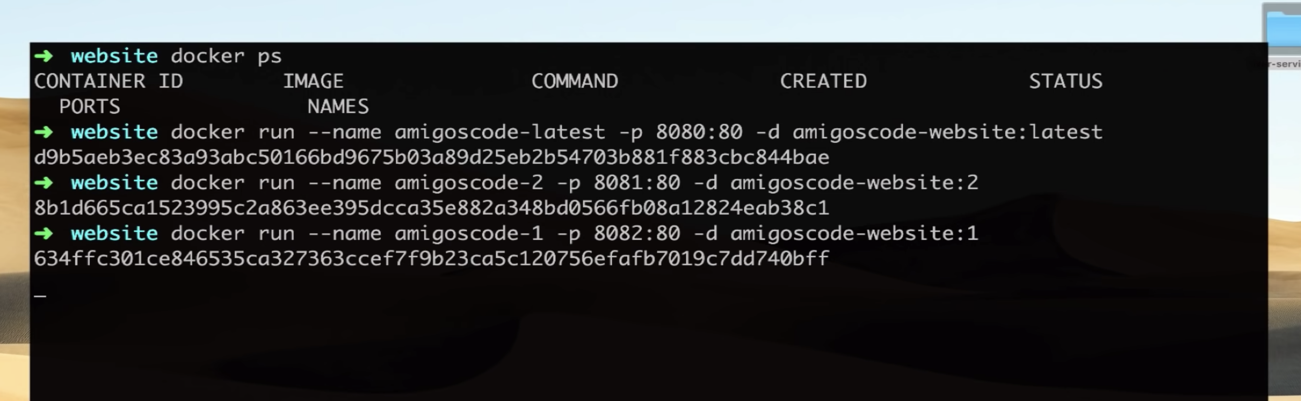

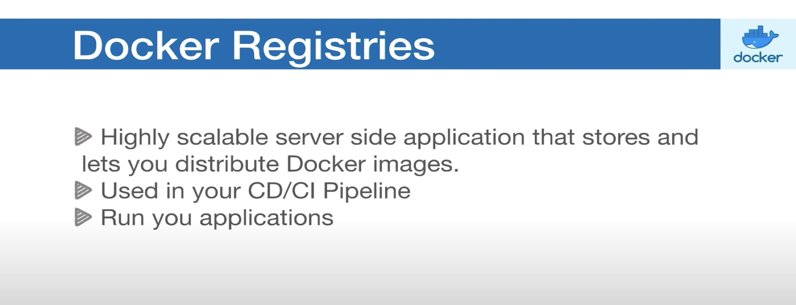

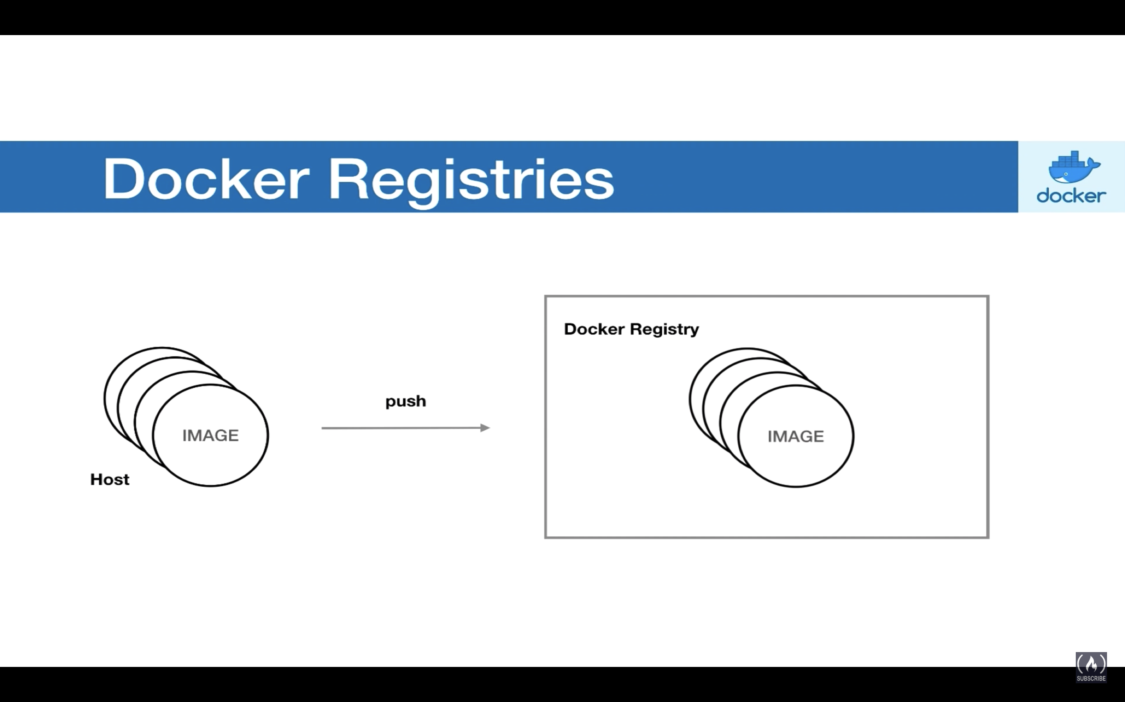

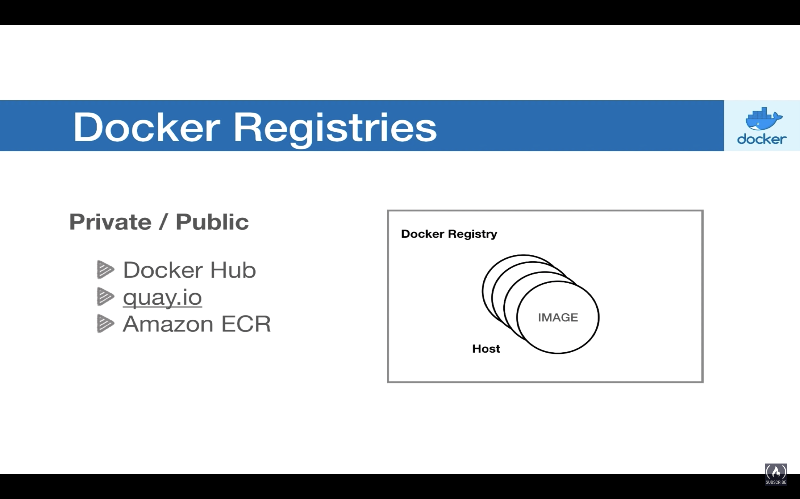

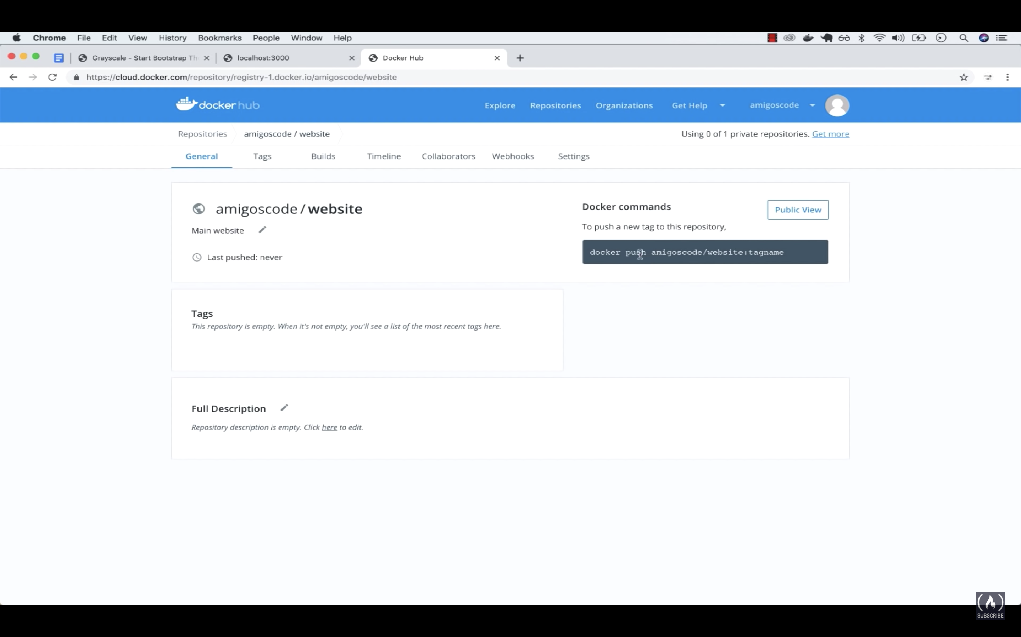

Docker push amigoscode/website:tagname

Here, amigoscode- Is the username

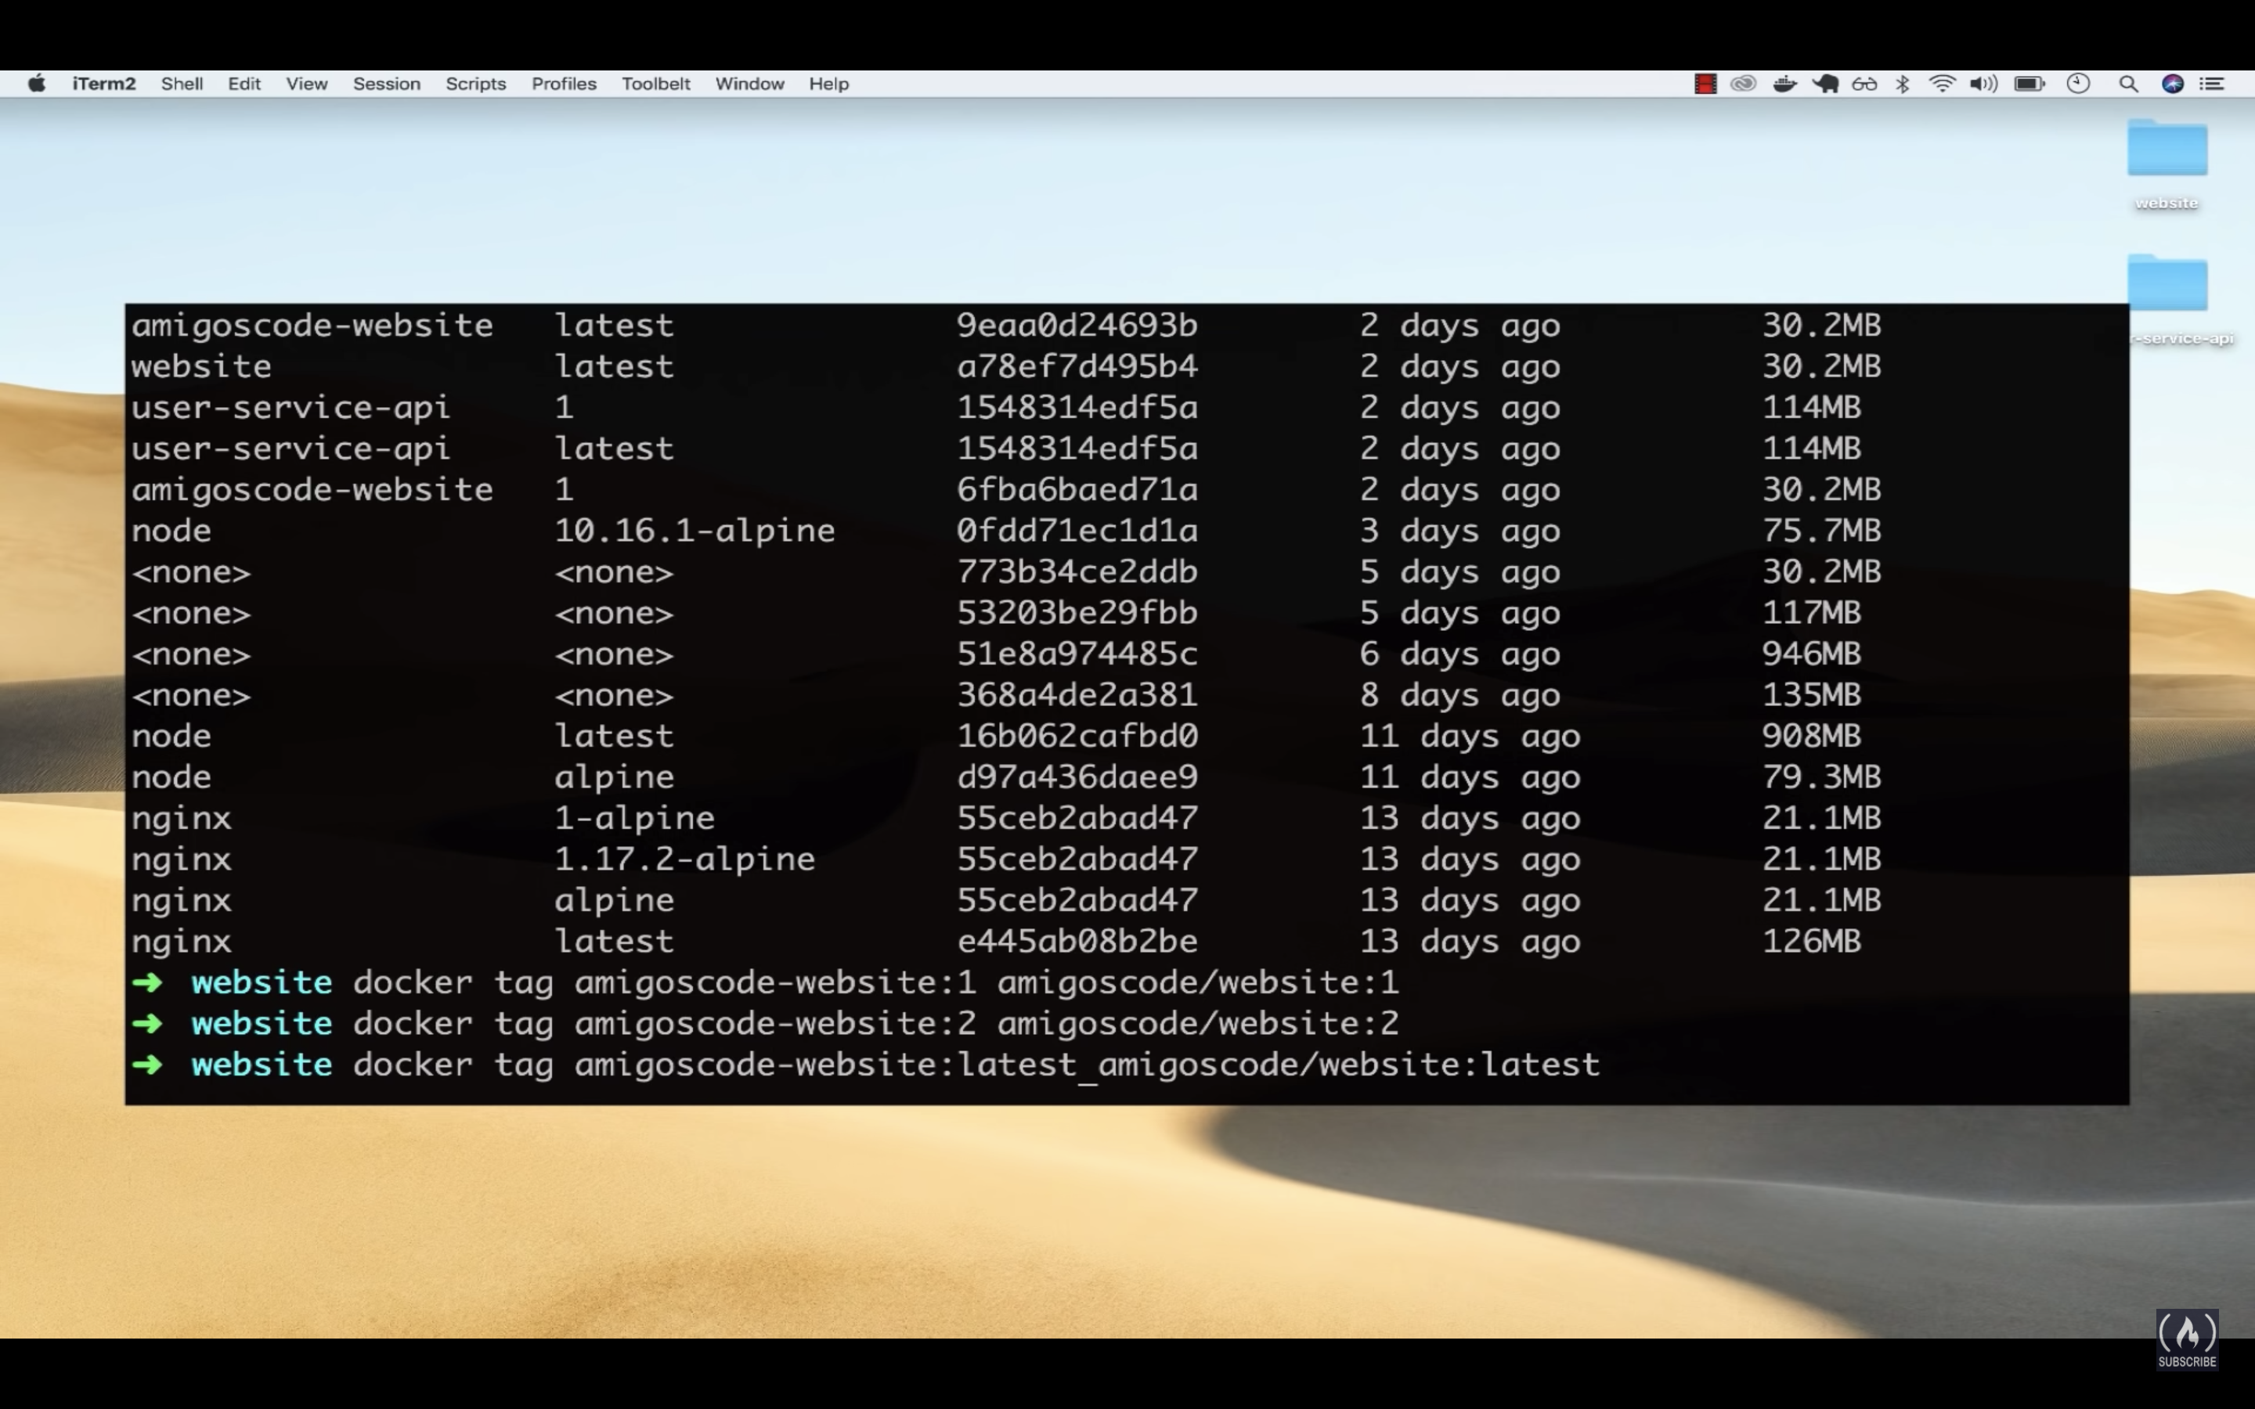

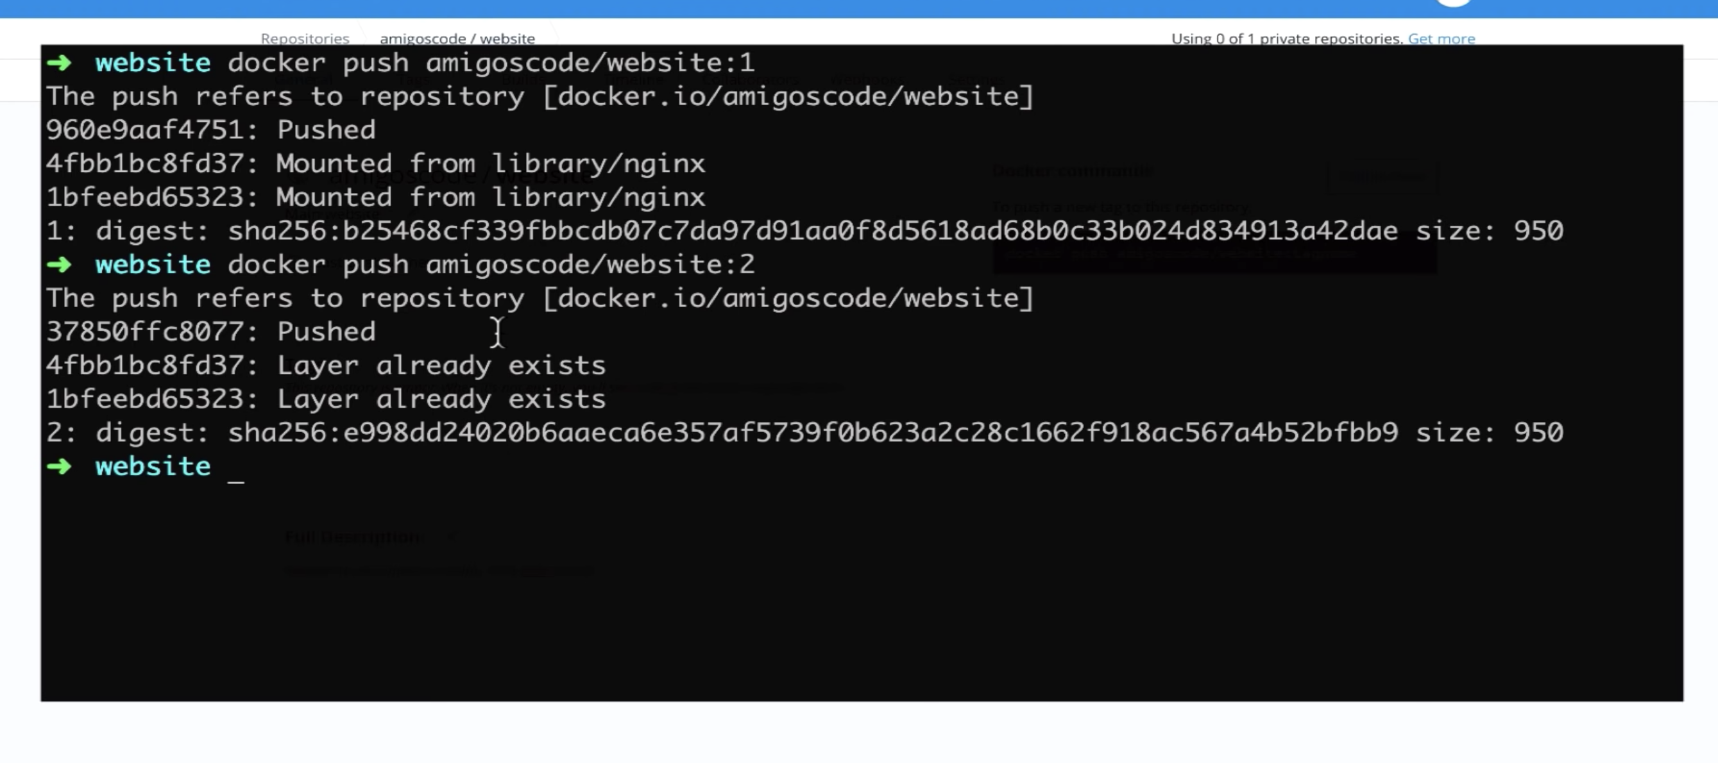

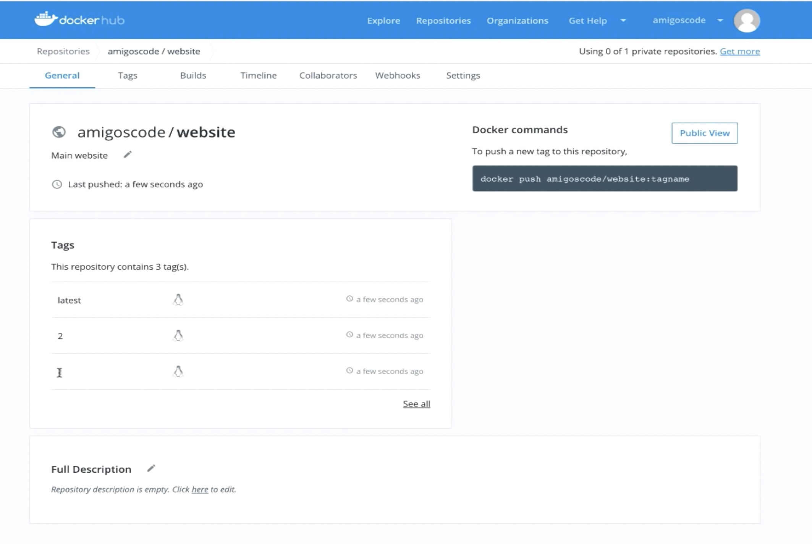

If you want to start the nginx container on port 8080(other than default port)

